Kubernetes

**Topics**

1. Kubernetes Overview
2. Setup Kubernetes
3. Kubernetes Concepts
4. YAML Introduction
5. Kubernetes Concepts-PODs, Replica Sets, Deployment
6. Networking in Kubernetes
7. Services
8. Microservices Architecture
9. Kubernetes on Cloud

**Kubernetes Overview**

* Kubernetes also known as K8s was built by Google based on their experience running containers in production.
* It is now an open-source project and is arguably one of the best and most popular container orchestration technologies out there.
* To understand Kubernetes, we must first understand two things-Container and Orchestration.

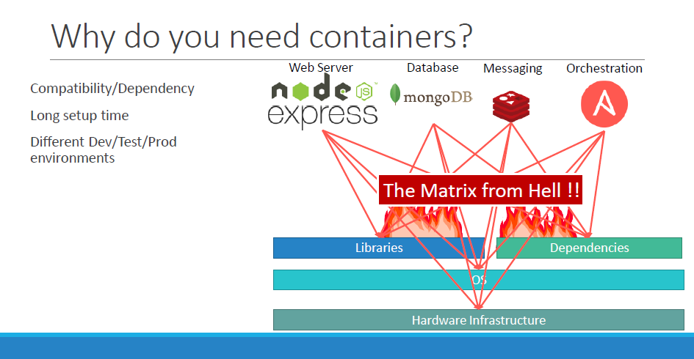

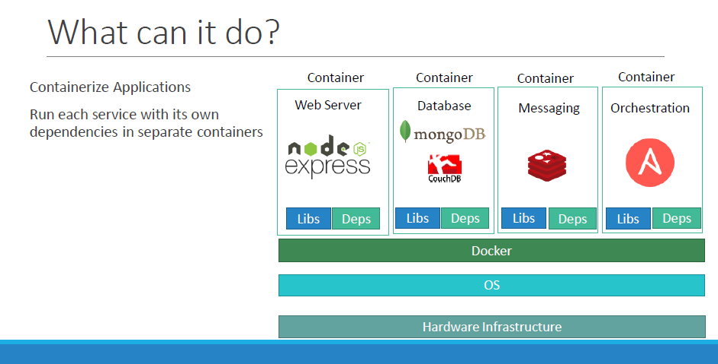

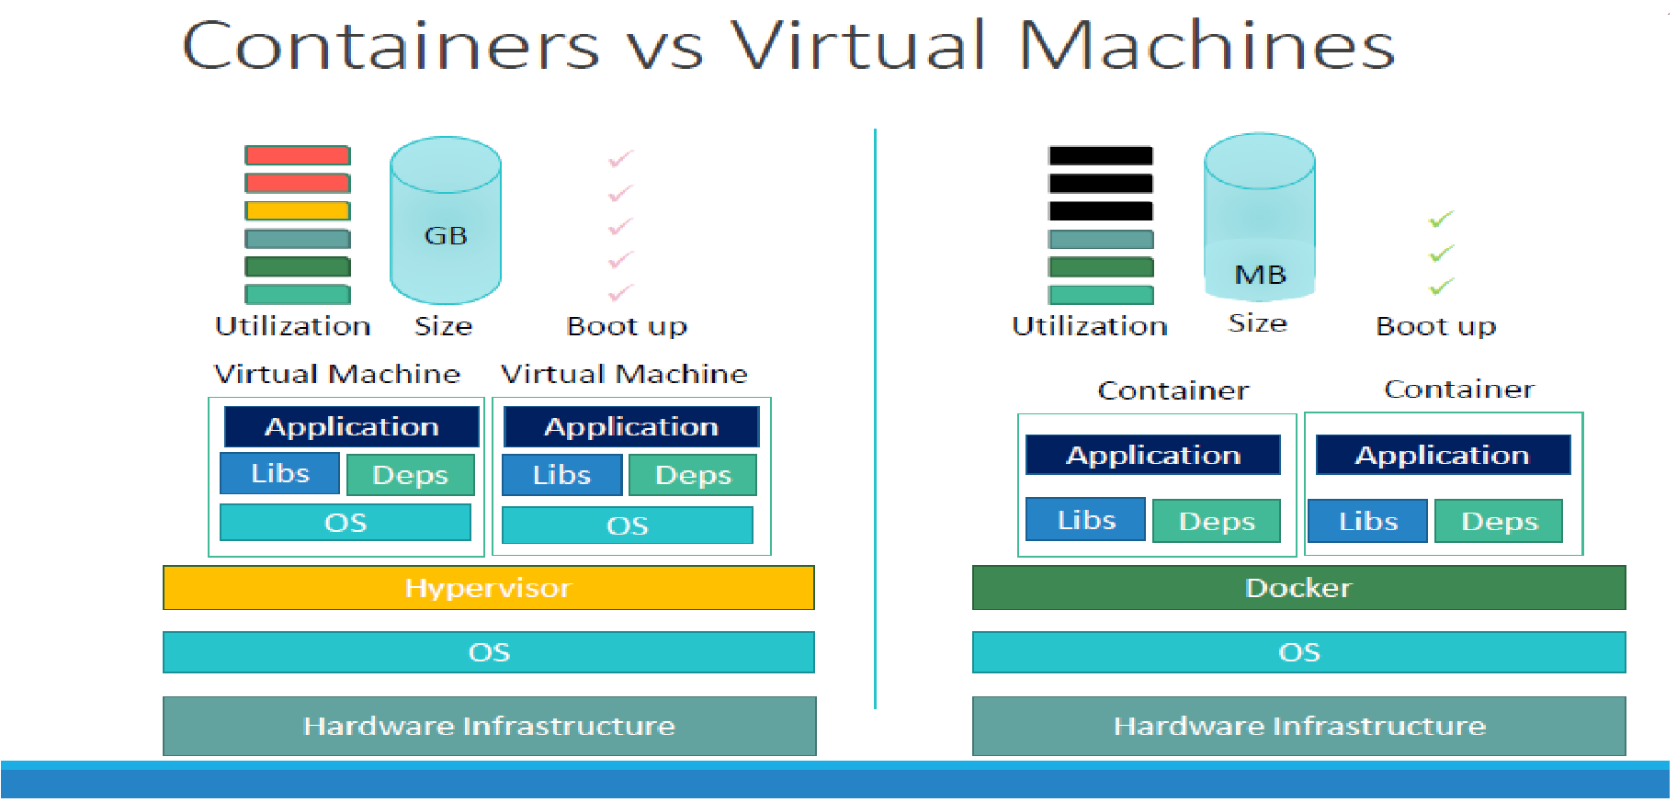

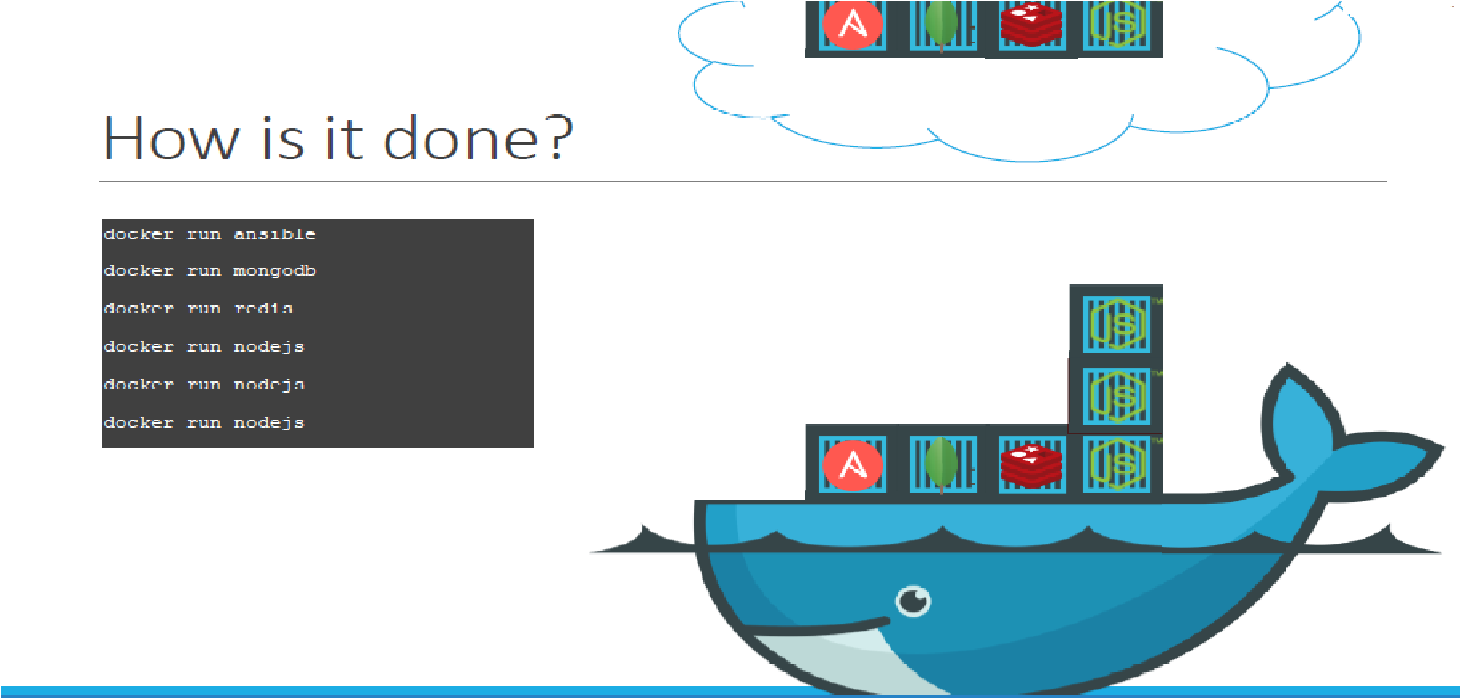

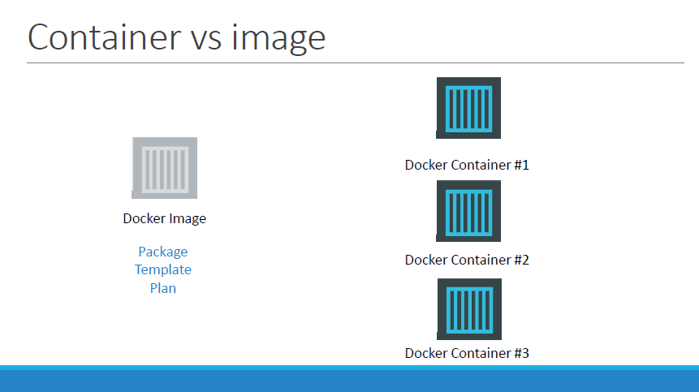

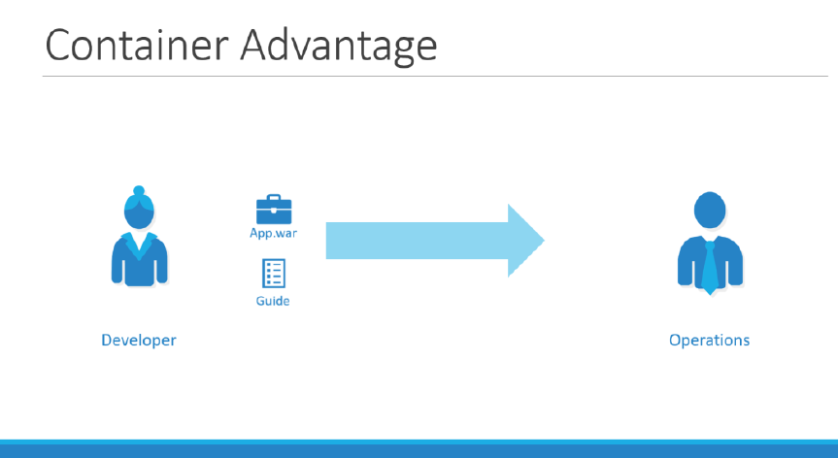

**Orchestration**

* **Orchestration** is the automated configuration, management, and coordination of computer systems, applications, and services etc.
* The platform which orchestrates the connectivity between the containers and automatically scale up or down based on the load. The whole process of automatically deploying and managing containers is known as Container Orchestration.
* **Orchestration Technologies**

1. *Docker Swarm (by Docker)*
2. *Kubernetes (by Google)*

* Kubernetes is most popular and is a bit difficult to setup and get started but provides a lot of options to customize deployments and supports deployment of complex architectures.
* Kubernetes is now supported on all public cloud service providers like GCP, Azure and AWS and the kubernetes project is one of the top ranked projects in Github.

1. *MESOS (by apache)*

* **Advantage of Kubernetes**
* There are various advantages of container orchestration. Your application is now highly available as hardware failures do not bring your application down because you have multiple instances of your application running on different nodes.

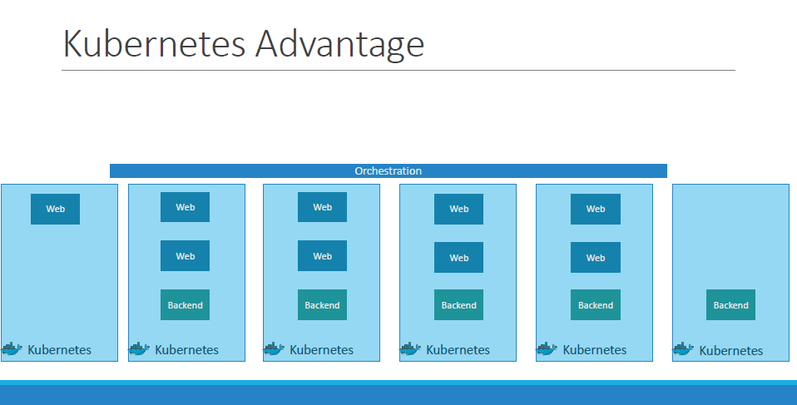

* The user traffic is load balanced across the various containers.
* When demand increases, deploy more instances of the application seamlessly and within a matter of second and we have the ability to do that at a **service** level.
* When we run out of hardware resources, scale the number of nodes up/down without having to take down the application

*We can do all these with the help of* ***declarative object*** *configuration file.*

**Archetecture**

* **Nodes (Minions)**
* A node is a physical or virtual machine on which Kubernetes is installed.
* A node is a **worker machine**, and this is where containers will be launched by the Kubernetes.

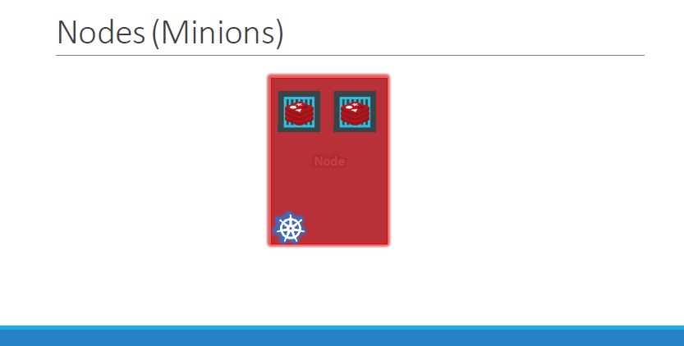

* It was also known as **Minions** in the past.
* **Use Case:**

1. What if the node on which our application is running is fails?

Ans: - Our application goes down.

Sol: - we need to have more than one node.

* **Cluster**
* A cluster is a set of nodes grouped together.

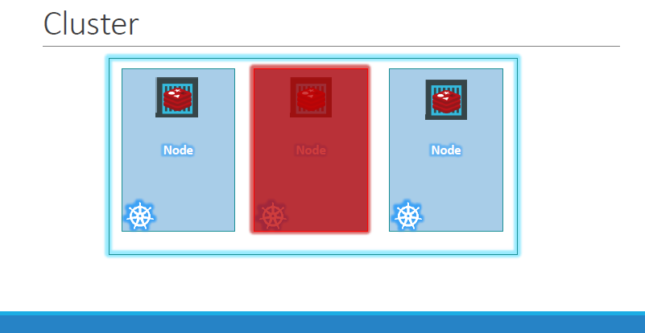

* In cluster ever if one node fails you have your application still accessible from the other nodes.
* Moreover, having multiple nodes helps in sharing load as well.

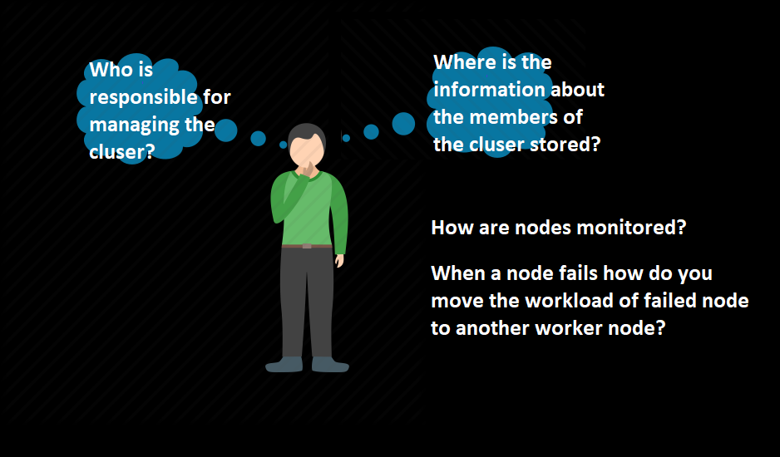

* **Master**
* The Master is another node with Kubernetes installed in it.
* It is configured as a Master node.

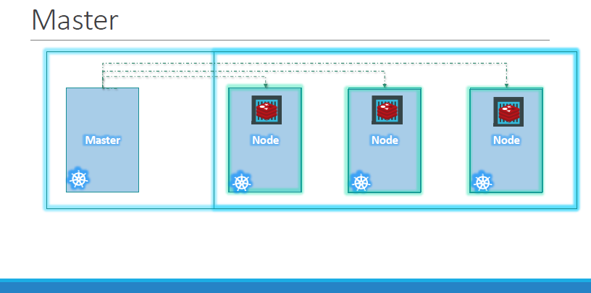

* The master keeps an eye over the nodes in the cluster and is responsible for the actual orchestration of containers on the worker nodes.

**Kubernetes Component**

* **Master node, Worker node and a set of components that make up Kubernetes.**

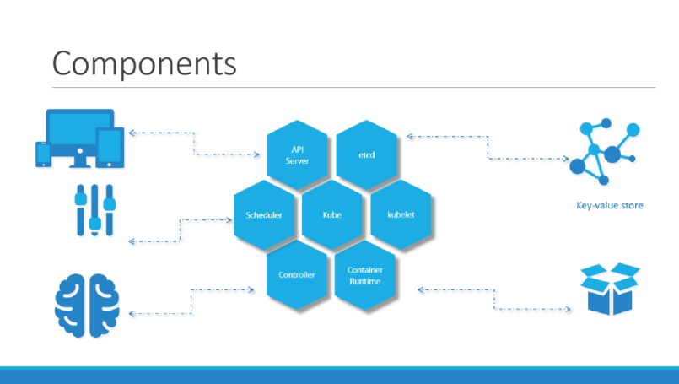

* When we install Kubernetes on a system, we are actually installing the following components.

1. **API Server**

* The API server acts as the front-end for the Kubernetes.
* The users, management devices, Command line interfaces all talks to the API server to interact with the Kubernetes cluster.
* acts as the frontend to the cluster. All external communication to the cluster is via the API-Server.

1. **ETCD Service**

* **etcd** is a key store. etcd is a distributed reliable key-value store used by Kubernetes to store all data used to manage the cluster.
* When we have multiple nodes and multiple masters in your cluster, **etcd** stores all that information on all the nodes in the cluster in distributed manner.
* **etcd** is responsible for implementing locks within the cluster to ensure there are no conflicts between the Masters.

1. **kubelet Service**

* kubelet is the agent that runs on each node in the cluster.
* The agent is responsible for making sure that the containers are running on the nodes as expected.

1. **Container Runtime**

* The container runtime is the underlying software that is used to run containers i.e. Docker.

1. **Controller**

* The controller is the brain behind orchestration.
* **Runs a set of controllers for the running cluster. The controller-manager implements governance across the cluster.**
* They are responsible for noticing and responding when nodes, containers and endpoints goes down.
* The controller makes decisions to bring up new containers in such cases.

1. **Scheduler**

* **schedules activities to the worker nodes based on events occurring on the etcd. It also holds the nodes resources plan to determine the proper action for the triggered event. For example the scheduler would figure out which worker node will host a newly scheduled POD.**
* The scheduler is responsible for distributing work or containers across multiple nodes.
* It looks for newly created containers and assigns them to Nodes.

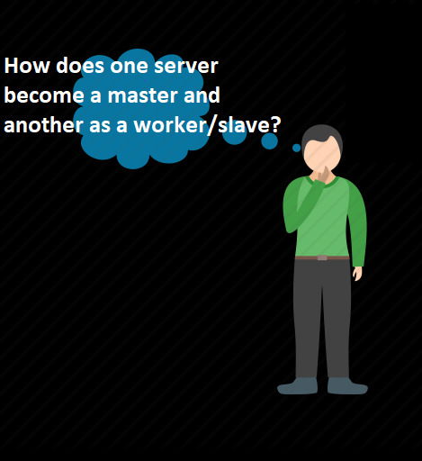

* The **worker node** is where the **containers** are hosted.
* To run docker containers on a system, we need a **container runtime** component installed.
* The **master node** has the **kube-apiserver** and that is **what makes it as master**.
* Similarly, the **worker nodes** have the **kubelet agent** that is responsible for interacting with the master to provide health info of the worker node and carry out actions required by the master requested by the master on the worker nodes.
* All the info gathered are stored in a key-value store on the **master node**. The value store is based on the popular **etcd framework**.
* The **master node** also has the **controller manager** and **scheduler**.

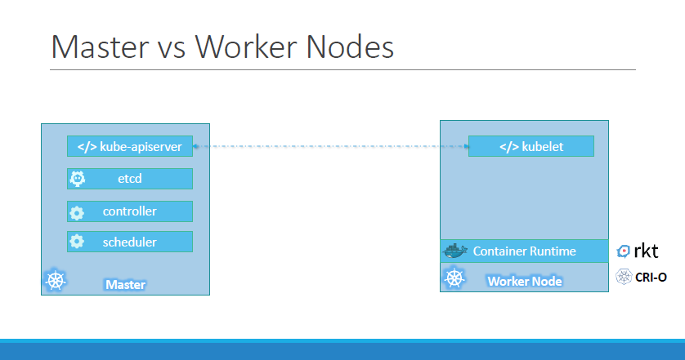

* **kubectl**
* **k**ubectl is command line utility tool, it is also called as kube control tool.
* kubectl is used to deploy and manage the applications on Kubernetes clusters. like get cluster information, get node status in the cluster etc.

**e.g.** **kubectl run hello-minikube (deploy an application on cluster)**

**kubectl cluster-info**

**kubectl get nodes**

**Kubernetes Concepts**

* PODS
* Replica Controller
* Replica Set
* Deployment
* Services
* Networking
* **PODS**
* **Prerequisite:**

1. **Kubernetes setup 2) Docker image of an application.**

* **Type:**

1. **Single Container POD 2) Multi Container POD**

* With Kubernetes our ultimate aim is to deploy our application in the form of containers on a set of machines that are configured as worker nodes in a cluster.
* However, Kubernetes does not deploy containers directly on the worker nodes.
* The containers are encapsulated into a Kubernetes object know as **PODs.**

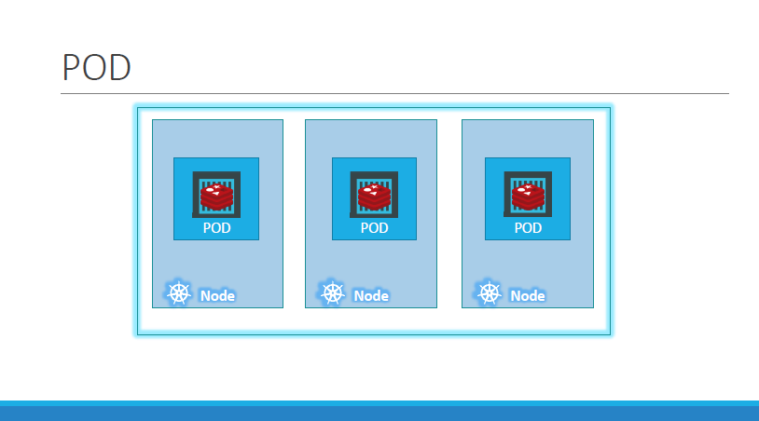

* A **POD** is a single instance of an application. A POD is the smallest object in Kubernetes.

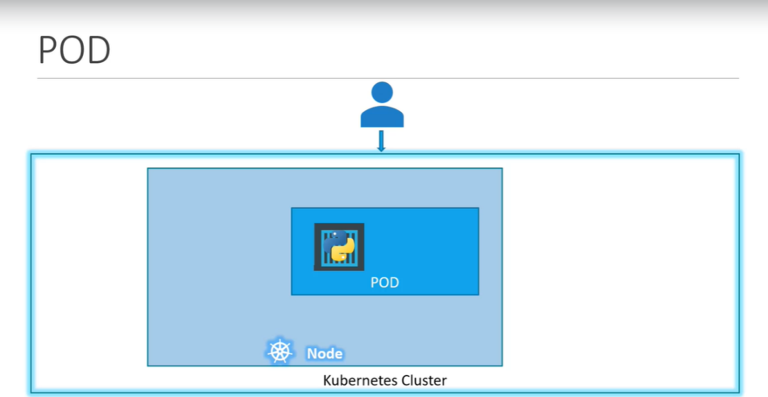

* **In above image we can see the simple case where you have a single node Kubernetes cluster with a single instance of your application running on the single docker container encapsulated in a POD.**
* **Use Case:**

1. What if the number of users accessing your application increases and you need to scale your application?

**Ans: -** you need to add additional instance of your web application to share the load.

1. Where would you spin up additional instance?

Do we bring up a new container instance within the same POD?

**Ans: -** No. We create a new POD altogether with a new instance of the same application.

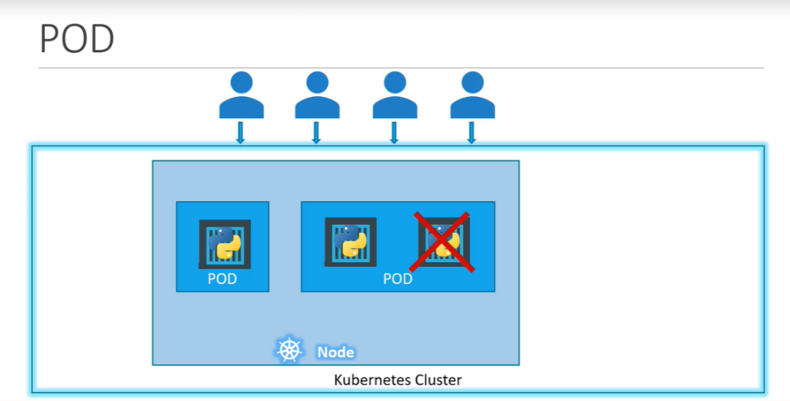

1. What if the user base further increases and the current node has no sufficient capacity?

**Ans: -** Then we can always deploy additional PODs on a new node in the cluster.

You will have a new node added to the cluster to expand the cluster’s physical capacity.

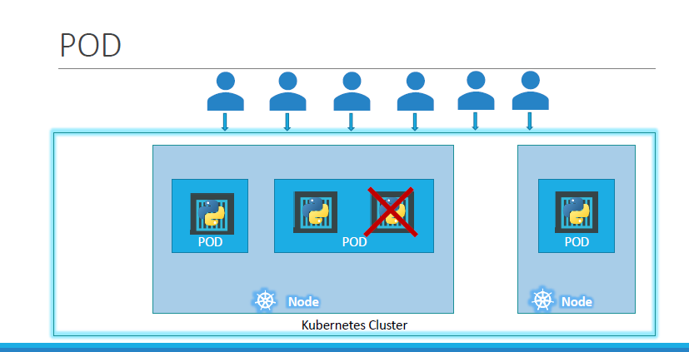

* **PODs usually have a one-to-one relationship with containers running your application.**
* **To scale UP you create new PODs and to scale down you delete PODs. You do not add additional containers to an existing POD to scale your application.**
* **Multi-Container POD**

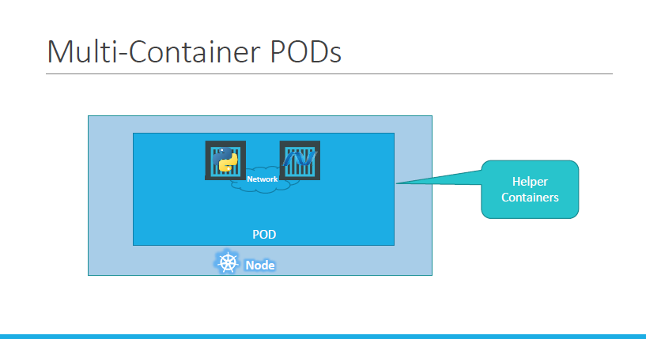

* sometimes you might have a scenario where you have a helper container, that might be doing some kind of supporting task for our web application such as processing a user entered data, processing a file uploaded by the user etc.
* you want these helper containers to live alongside your application container. In that case, you can have **both of these containers part of the same POD**.
* when a new application container is created, the helper is also created and when it dies the helper also dies since they are part of the same POD.

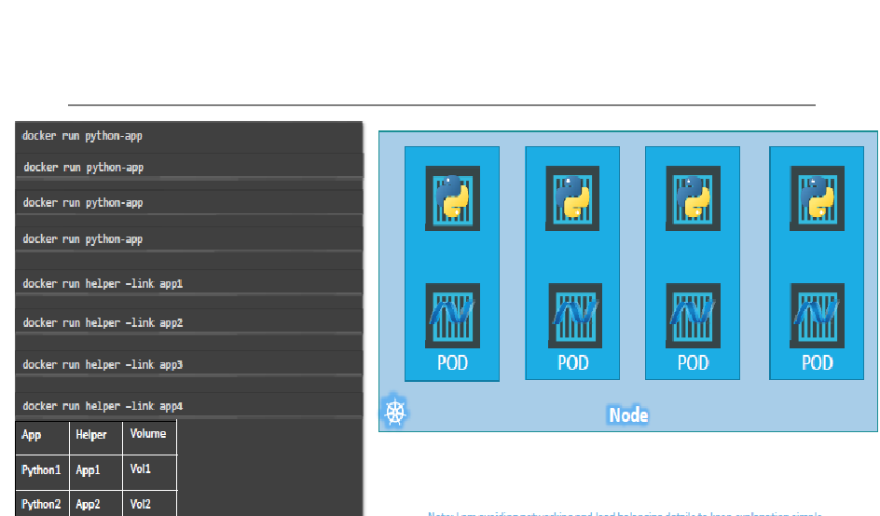

* **Deployment of PODs**
* **Kubectl run** command is used to deploy a docker container by creating a POD. So, it first creates a POD automatically and deploys an instance of the application (like nginx) docker image.

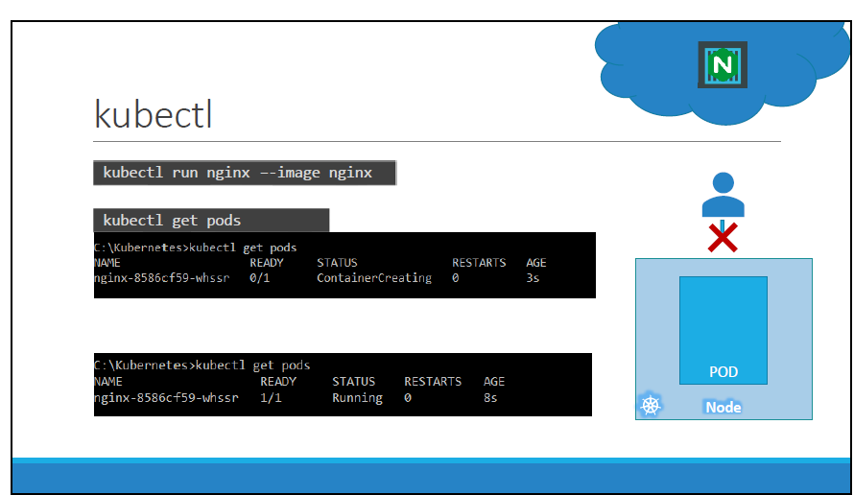

**Kubernetes Definition file (YAML)**

**Talk about properties, list/array/dictionary**

**Exercise**

**YAML in Kubernetes**

* Kubernetes uses YAML files as input for the creation of objects such as PODs, Replicas, Deployments, services etc.
* A Kubernetes definition file always contains 4 top level fields/properties

1. *apiVersion*

* Version of the Kubernetes API we’re using to create the object.
* Depending on what we are trying to create we must use the right apiVersion.

1. *kind*

* Type of object we are trying to create. Like Pod, Service, Deployment etc.

1. *metadata*

* The data about the object like its name, labels etc.

1. *spec*

Depending on the object which we are going to create, this is the place where we provide additional information to the Kubernetes pertaining to that object.

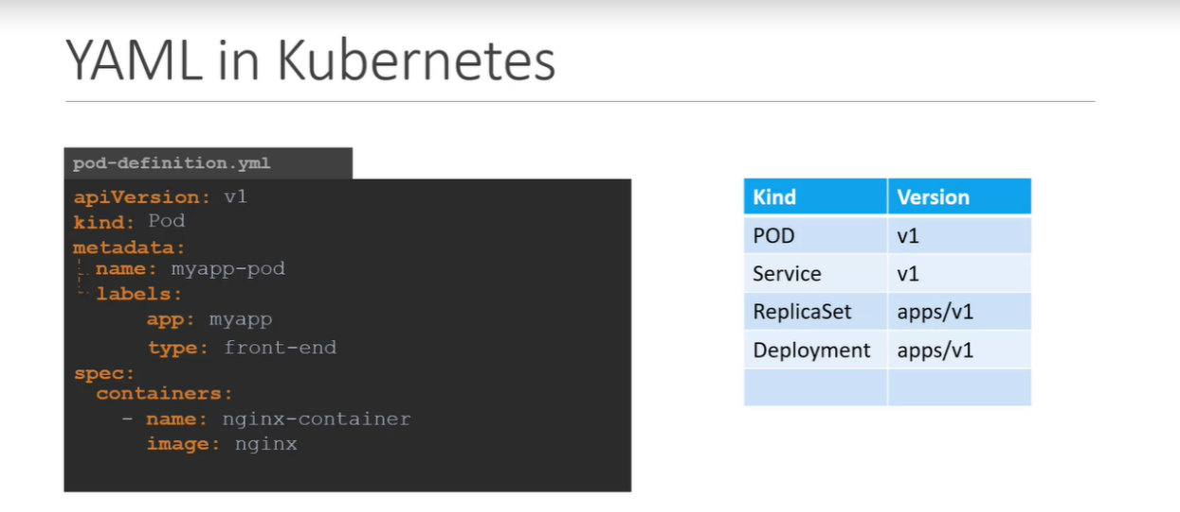

**Kubectl apply**

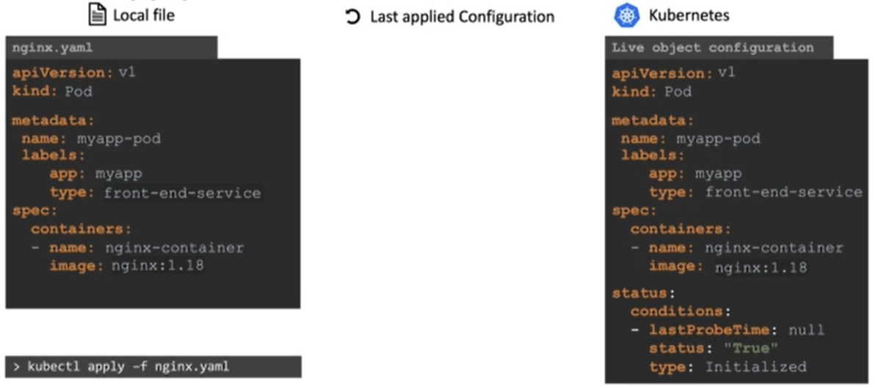

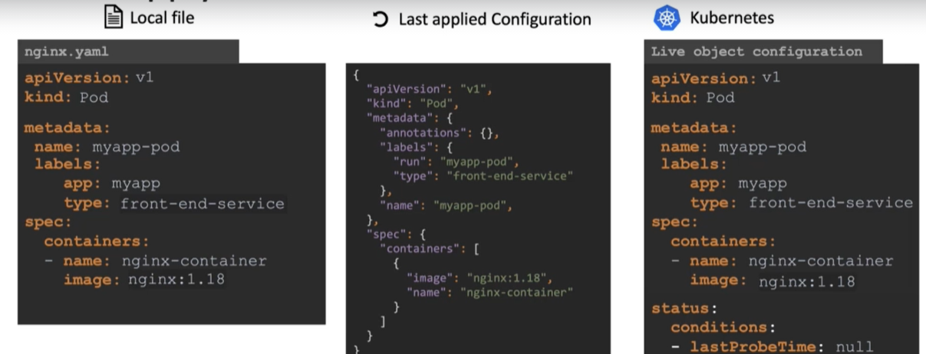

* changing version from **nginx:1.18** to **nginx:1.19**

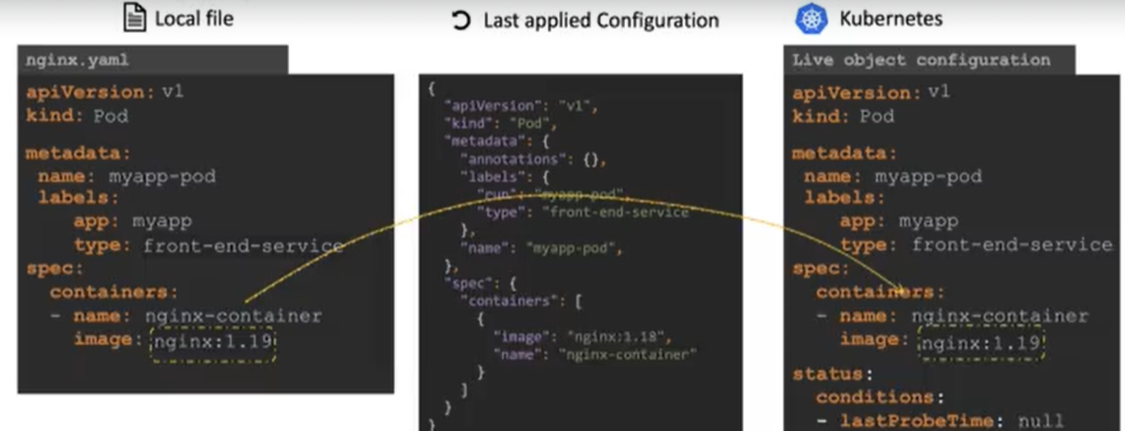

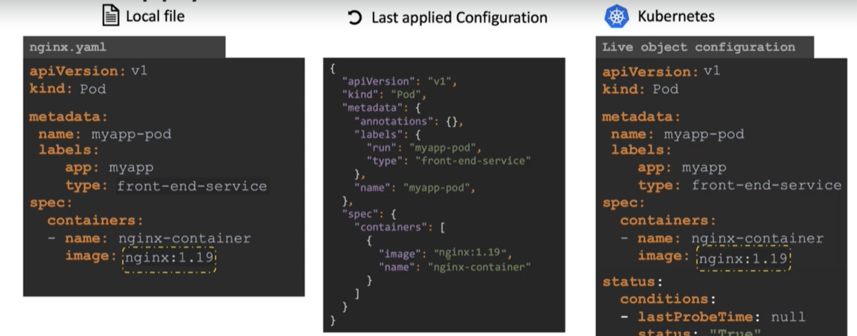

* Last applied configuration is saved under annotations object in metadata

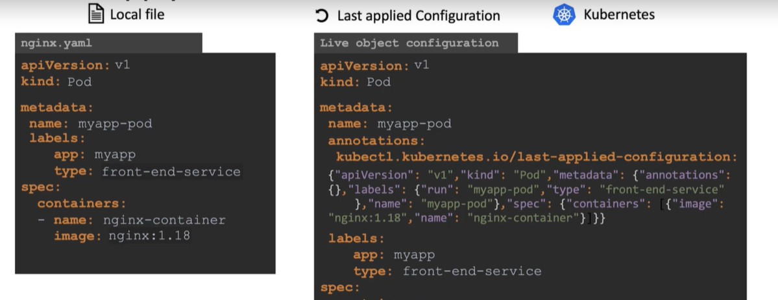

* **Commands: -**
* **kubectl run <pod-name> --image=<image-name>**
* **Kubectl create -f <pod-definition file>**
* **kubectl apply -f < pod-definition file> ( Create and apply we can use interchangeable)**
* **Kubectl get pods**
* **Kubectl get pods -o wide ( it shows pod info along with ip and node)**
* **Kubectl describe pod <pod-name>**
* **kubectl delete pod <pod-name>**
* **kubectl edit pod <pod-name>**
* **kubectl run <pod-name> --image=<image-name> --dry-run=client -o yaml > pod.yml**

***NOTE:***

* While compilers and linters do a good job to detect errors in pull-requests for code, a good validation is missing for Kubernetes configuration files. The existing solution is to run kubectl apply --dry-run, but this runs a *local* dry-run that doesn't talk to the server: it doesn't have server validation and doesn't go through validating admission controllers.

**Replication Controller**

* Controllers are the brain behind Kubernetes.
* They are processes that monitor Kubernetes object and respond accordingly.

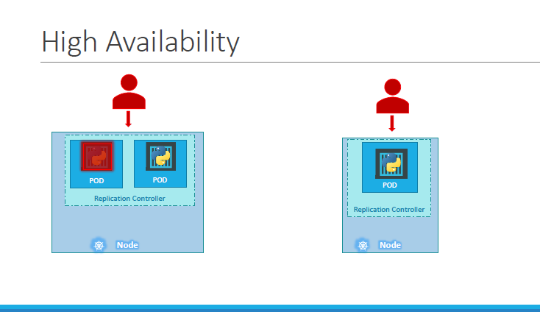

* The replication controller helps us run multiple instances of a single POD in the Kubernetes cluster thus providing high availability.
* The replication controller ensures that the specified number of PODs are always running. Even if its just 1 or n-number.
* Another reason we need replication controller is to create multiple PODs to share the load across them.

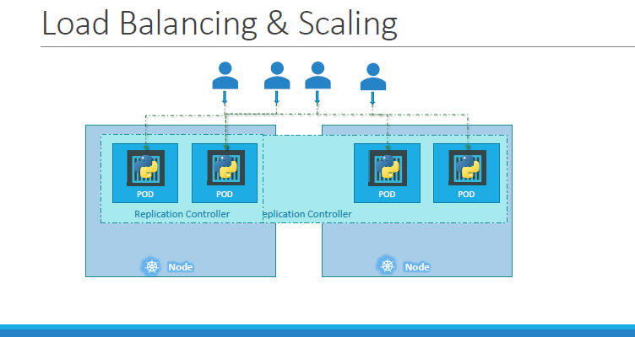

* When the number of users increase, we deploy additional POD to balance the load across the two pods.
* If the demand further increases and If we were to run out of resources on the first node, we could deploy additional PODs across other nodes in the cluster.
* Replication controller spans across multiple nodes in a cluster.

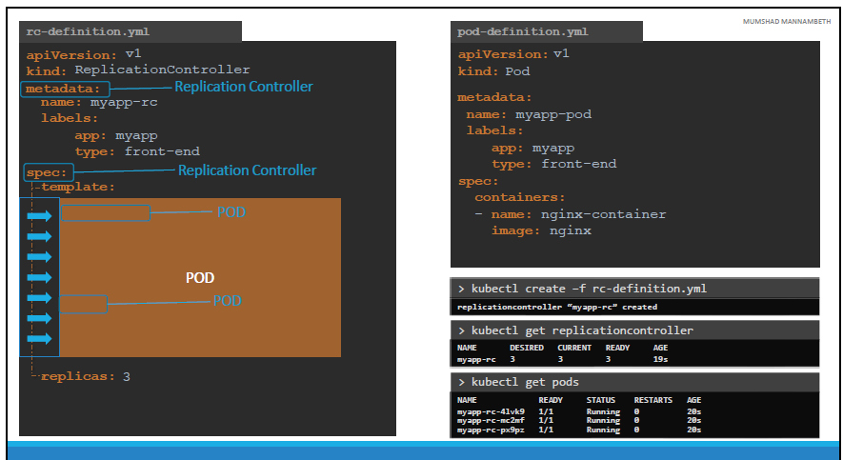

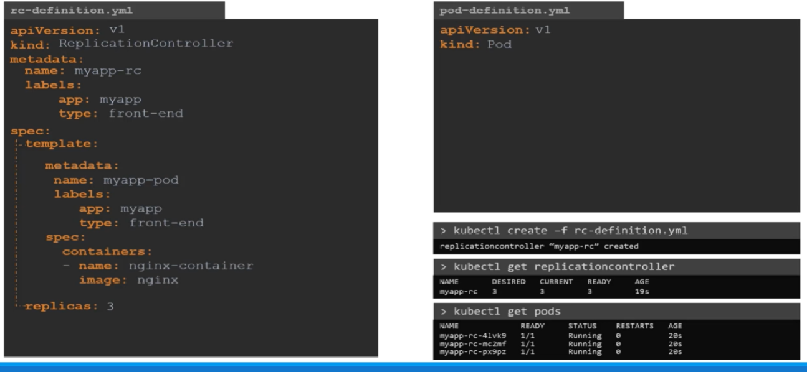

**ReplicaSet**

* Replication Controller is the older technology that is being replaced by Replica Set.
* There is one major difference between replication controller and replica set. Replica set requires a selector definition.
* The selector section helps the replica set to identify what pods fall under it.

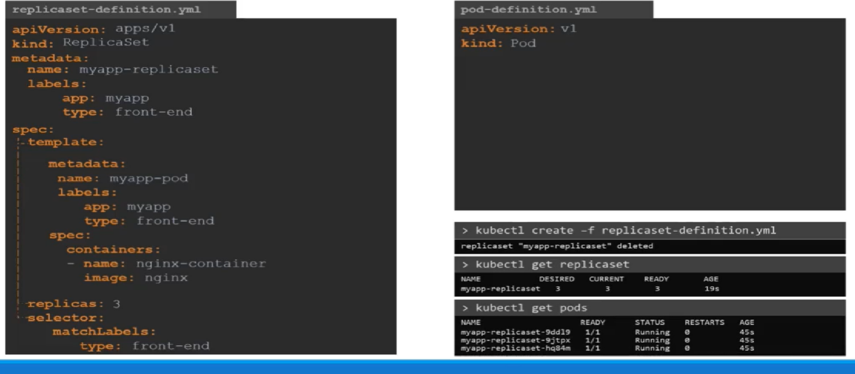

**Labels and Selectors**

* Labels we use as the filter for the replicaset.
* Under the selector section we use the **matchLabelsfilter** and provide the same label that we used while creating the pods. This way the replicaset knows which pods to monitor.

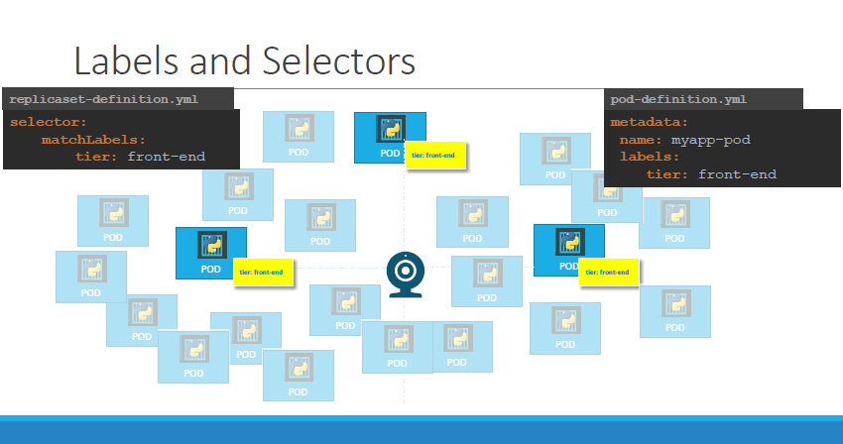

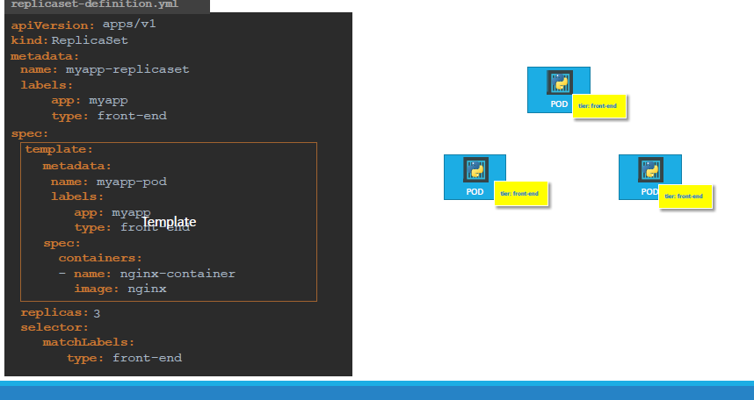

**Scaling**

Let’s Say we started with 3 replicas and in the future, we decide to scale to 6. How do we update our replicaset to scale to 6 replicas?

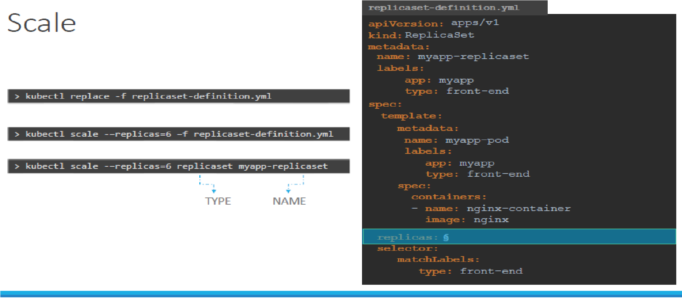

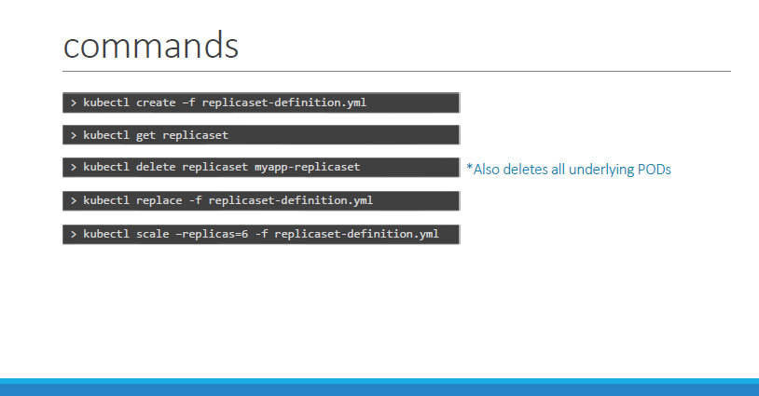

* ***Command*: -**
* **kubectl create -f <replicaset-definition.yaml>**
* **kubectl delete pod <pod-name>**
* **kubectl describe replicaset <replicaset-name>**

**###For scale up and down##**

* **kubectl edit replicaset <replicaset-name> (update the Kubernetes object at runtime)**
* **kubectl scale replicaset <replicaset-name> --replicas=2**

**Deployment**

* The **deployment** provides us with capabilities to **upgrade** the underlying instances seamlessly using **rolling updates**, **undo changes**, and **pause** and **resume changes to deployments**.
* Take an example we have a web server that needs to be deployed in a production environment. We need not ONE, but many such instances of the web server running for obvious reasons.
* Secondly, when newer versions of application builds become available on the docker registry, we would like to UPGRADE ours docker instances seamlessly.
* However, when we upgrade ours instances, we do not want to upgrade all of them at once. This may impact users accessing our applications, so we may want to upgrade them one after the other. And that kind of upgrade is known as **Rolling Updates**.

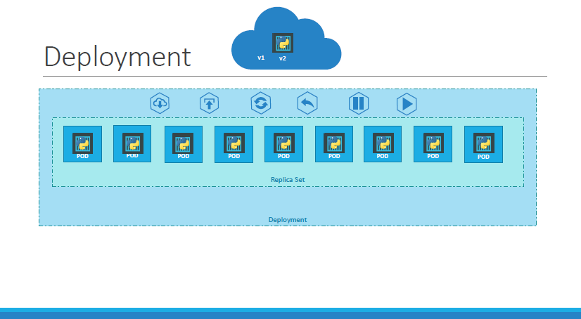

* Suppose one of the upgrades we performed resulted in an unexpected error and we are asked to undo the recent update. You would like to be able to **roll back** the changes that were recently carried out.
* Environment related changes like **upgrading** underlying webserver version, **scaling** changes, **resource allocation** etc.
* We do not want to apply each change immediately after the command is run, instead you would like to apply a pause to your environment, make the changes and then resume so that all changes are rolled-out together.
* **All the above-mentioned capabilities are available with the Kubernetes Deployment.**

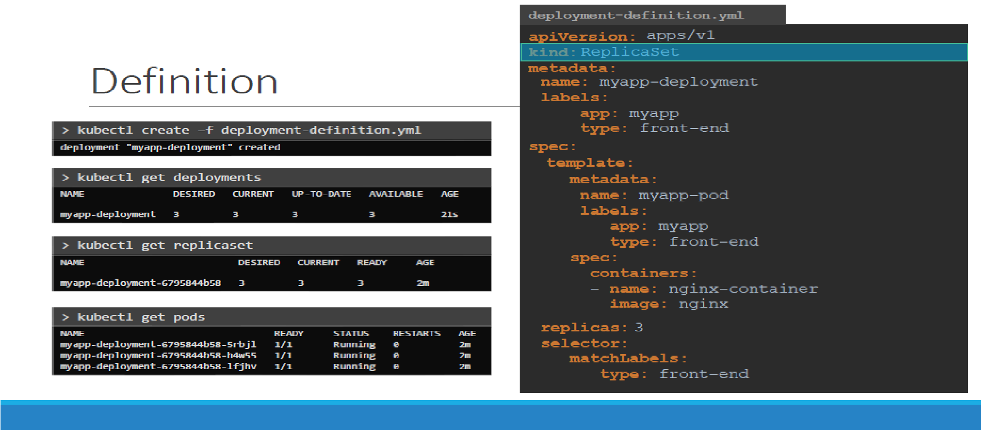

* ***Command:-***
* **Kubectl get all (To get all created object in a cluster at once like pods, replicaset, Deployment)**

**Rolloout and Versioning**

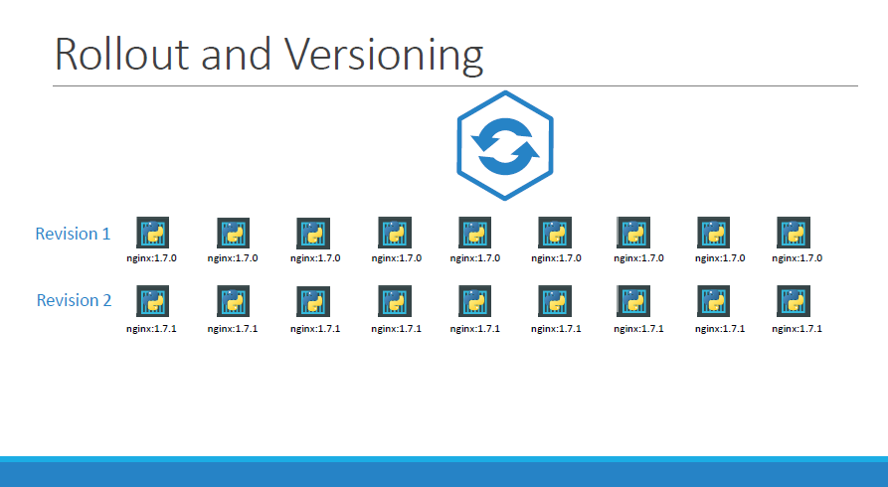

* **Whenever you create a new deployment or upgrade the images in an existing deployment it triggers a Rollout.**
* A rollout is the process of gradually deploying or upgrading your application containers.
* When you first create a deployment, it triggers a rollout. A new rollout creates a new Deployment revision.
* Revision helps us keep track of the changes made to our deployment and enables us to roll back to a previous version of deployment if necessary.

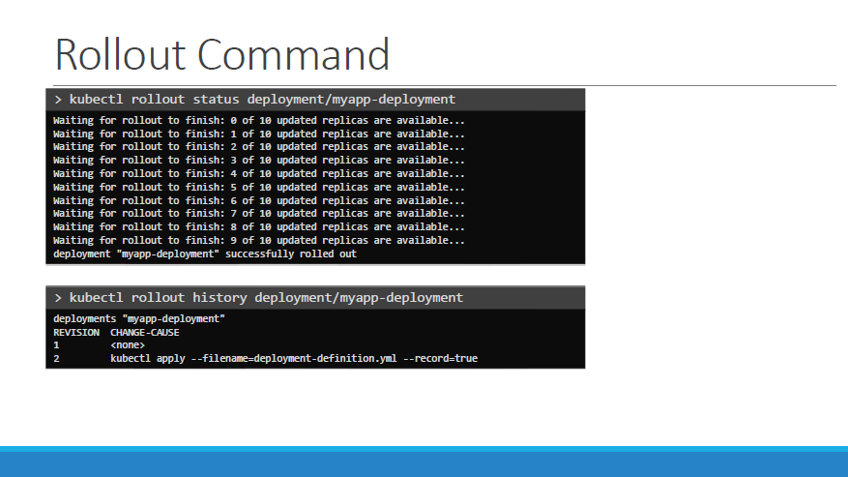

**Deployment Strategy**

* Remember, if you do not specify a strategy while creating the deployment, it will assume it to be Rolling Update. In other words, RollingUpdate is the default Deployment Strategy.

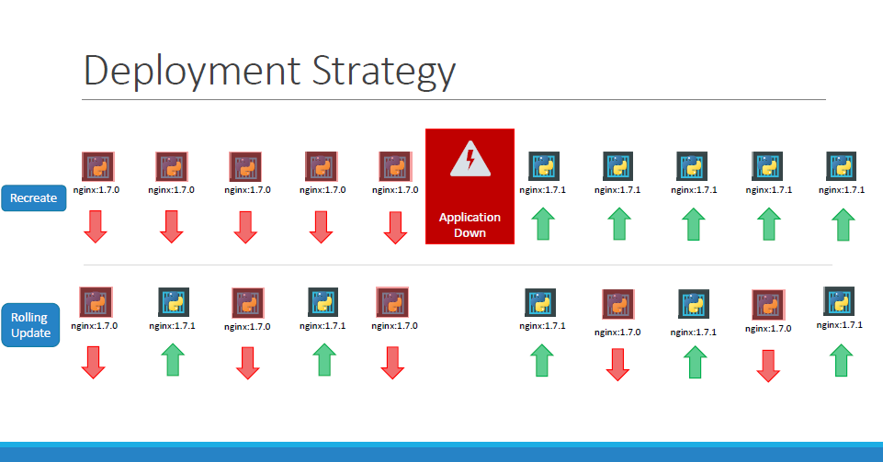

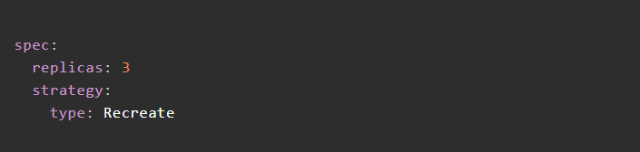

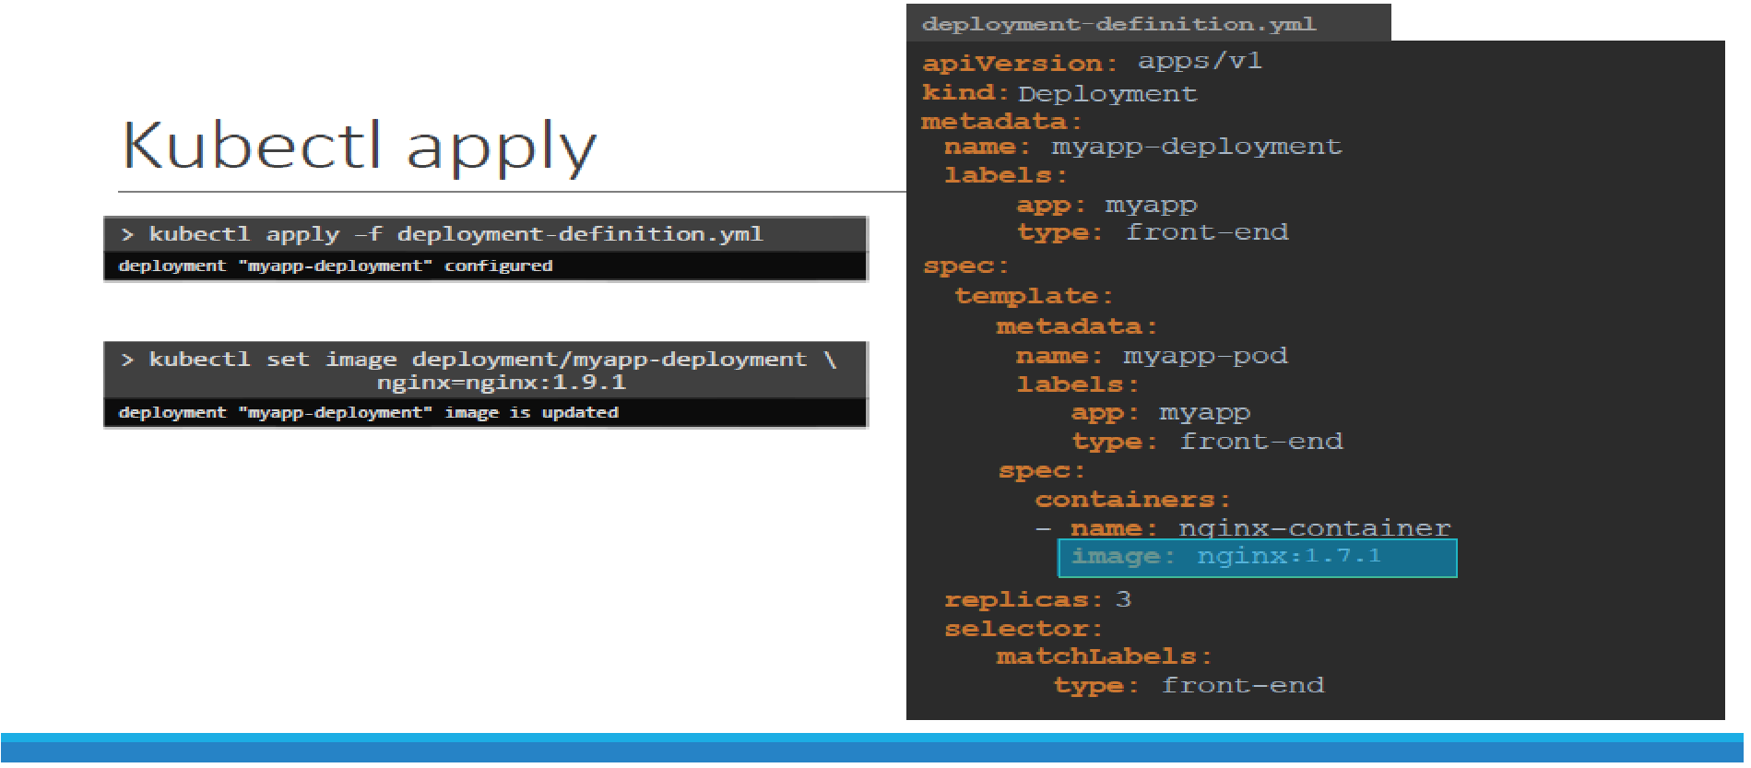

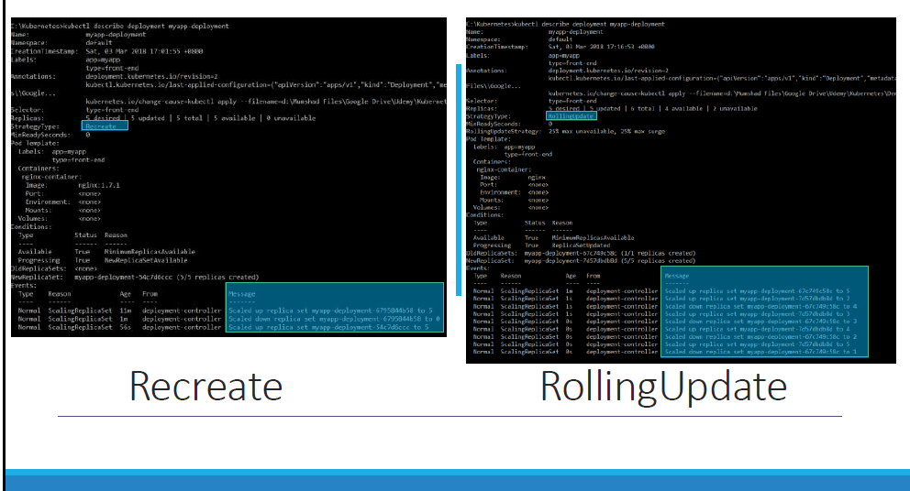

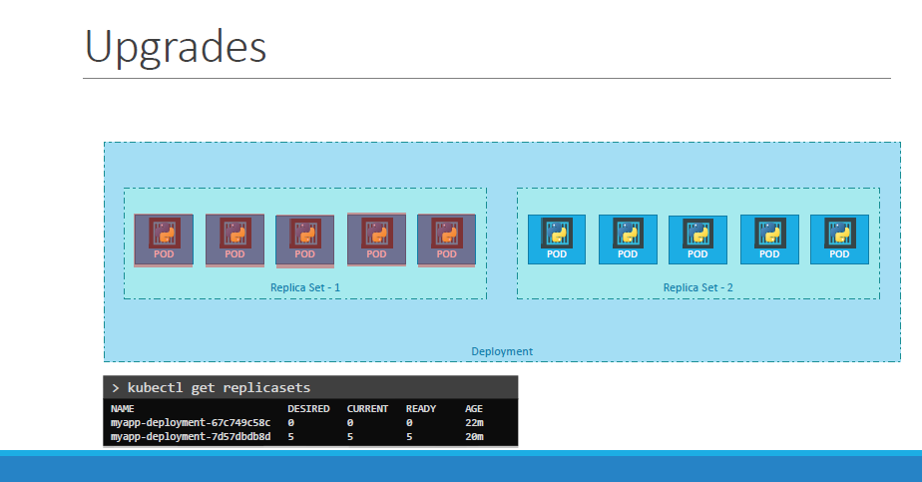

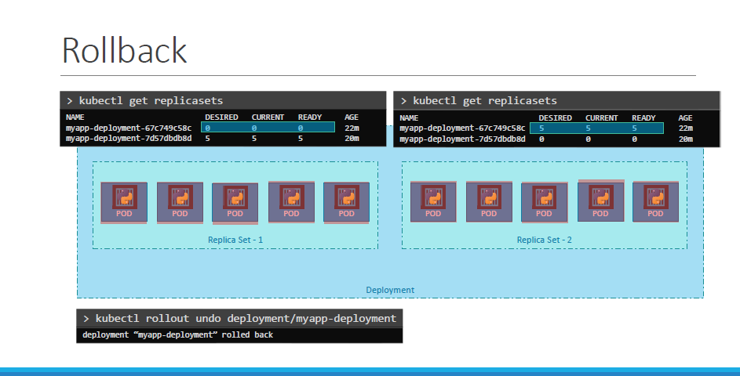

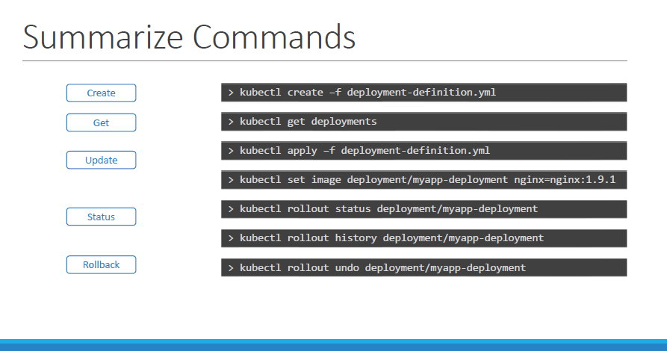

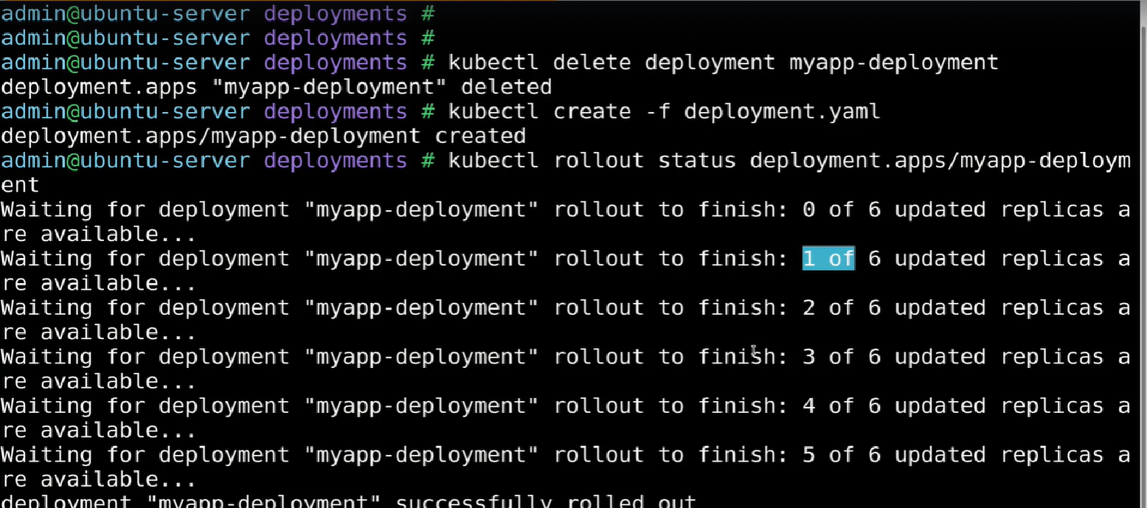

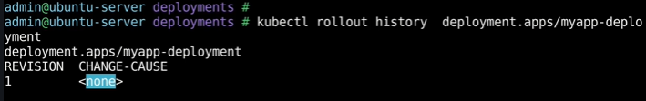

* ***Commands: -***
* **kubectl create -f <deployment-file-name>**
* **kubectl rollout status deployment.app/<deployment-name> (Status of deployment)**
* **kubectl delete deployment <deployment-name>**
* **kubectl rollout history deployment.app/myapp-deployment (History of deployment)**
* **kubectl create -f deployment.yaml --record (record instruct the kubernetes to record cause of change)**
* **kubectl set image deployment myapp-deployment nginx=nginx:1.18-perl ( to change the image version of deployement)**
* **kubectl rollout undo deployment/myapp-deployment**

**Networking in Kubernetes**

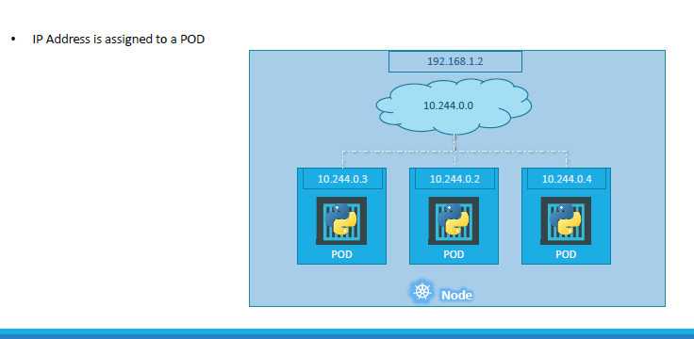

* We will start with a **single node kubernetes cluster**.
* The node has an IP address, say it is 192.168.1.2 in this case. This is the IP address we use to access the kubernetes node.
* So on the single node kubernetes cluster we have created a Single POD. As you know a POD hosts a container. Unlike in the **docker world** were an IP address is always **assigned to a Docker CONTAINER**,in **Kubernetes** the IP address is assigned to **a POD**.
* Each POD in kubernetes gets its own internal IP Address. In this case its in the range 10.244 series and the IP assigned to the POD is 10.244.0.2.
* ***So how is it getting this IP address?***
* When Kubernetes is initially configured it creates **an internal private network** with the address 10.244.0.0.and all PODs are attached to it.
* When you deploy **multiple PODs**, they all get a **separate IP assigned**. The PODs can communicate to each other through this IP.
* ***But accessing other PODs using this internal IP address MAY not be a good idea as its subject to change when PODs are recreated.***

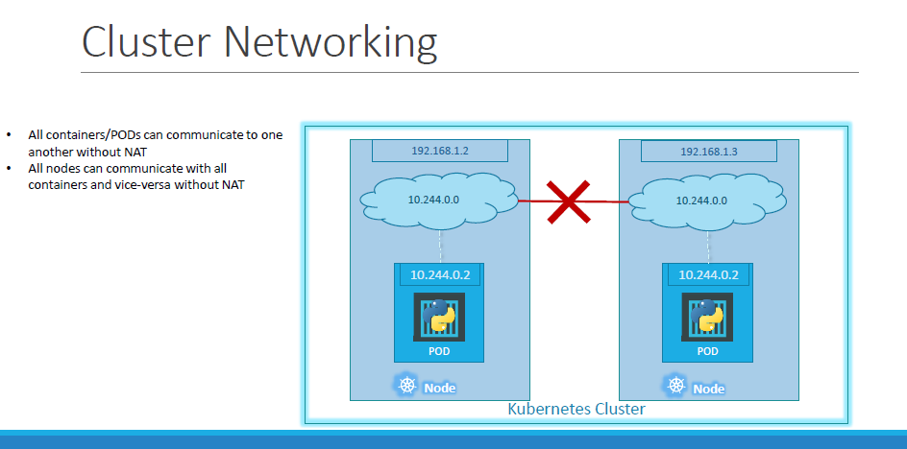

* how does it work when you have multiple nodes in a cluster?
* In this case we have two nodes running kubernetes and they have IP addresses 192.168.1.2 and 192.168.1.3 assigned to them. Note that **they are not part of the same cluster yet**. Each of them has a single POD deployed.
* pods are attached to an internal network and they have their own IP addresses assigned. HOWEVER, if you look at the network addresses, you can see that they are the same.
* The two networks have an address 10.244.0.0 and the PODs deployed have the same address too.
* This is **NOT** going to work well when the **nodes are part of the same cluster**. The PODs have the same IP addresses assigned to them and that will lead to **IP conflicts in the network**. Now that’s ONE problem.
* When a kubernetes cluster is setup, kubernetes **does NOT automatically setup any kind of networking to handle these issues**.
* kubernetes expects us to setup networking to meet certain fundamental requirements. Some of these are that all the containers or PODs in a kubernetes cluster MUST be able to communicate with one another without having to configure NAT.
* All nodes must be able to communicate with containers and all containers must be able to communicate with the nodes in the cluster. Kubernetes expects US to setup a networking solution that meets these criteria.

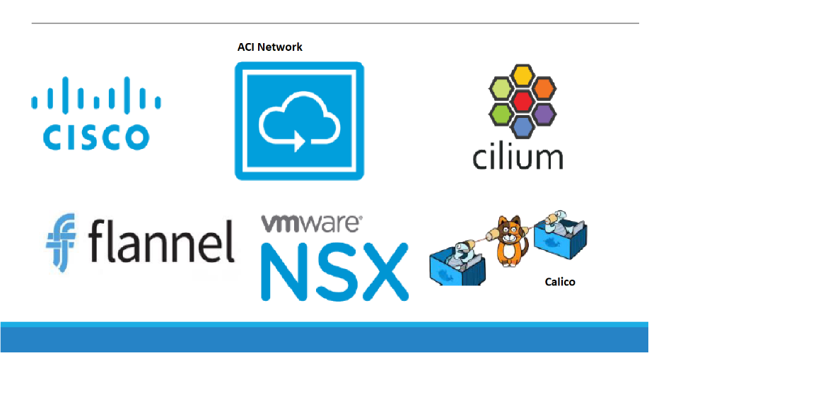

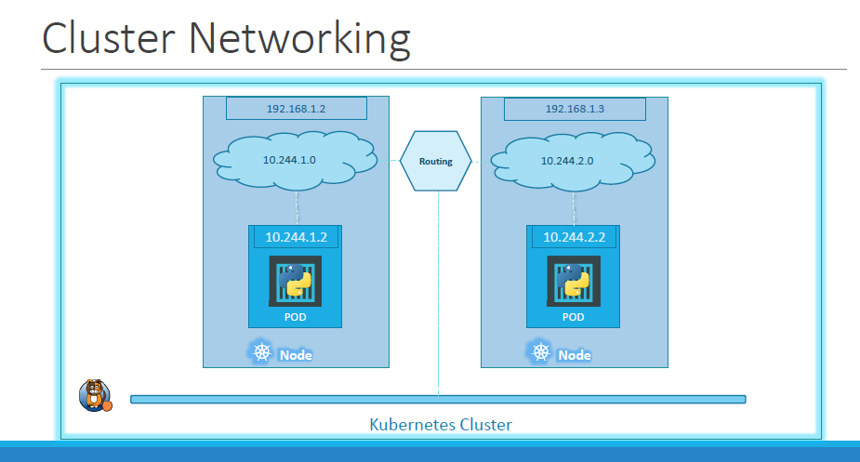

* **with the Calico networking setup, it now manages the networks and IPs in my nodes and assigns a different network address for each network in the nodes.**
* **This creates a virtual network of all PODs and nodes** **where they are all assigned a unique IP Address**. And by using simple routing techniques the cluster networking enables communication between the different PODs or Nodes to meet the networking requirements of kubernetes.
* Thus, all PODs can now communicate to each other using the assigned IP addresses.

**Service**

* Kubernetes Services enable **communication between various components** **within** and **outside** of the application.
* **Kubernetes Services helps us connect applications together with other applications or users**. For example, our application has groups of PODs running various sections, such as a group for serving front-end load to users, another group running back-end processes, and a third group connecting to an external data source.

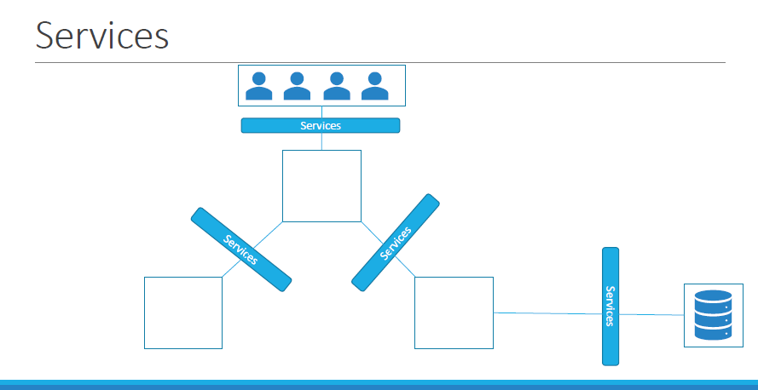

* It is Services that enable connectivity between these groups of PODs. Services enable the front-end application to be made available to users, it helps communication between back end and front-end PODs, and helps in establishing connectivity to an external data source. **Thus, services enable loose coupling between microservices in our application**.

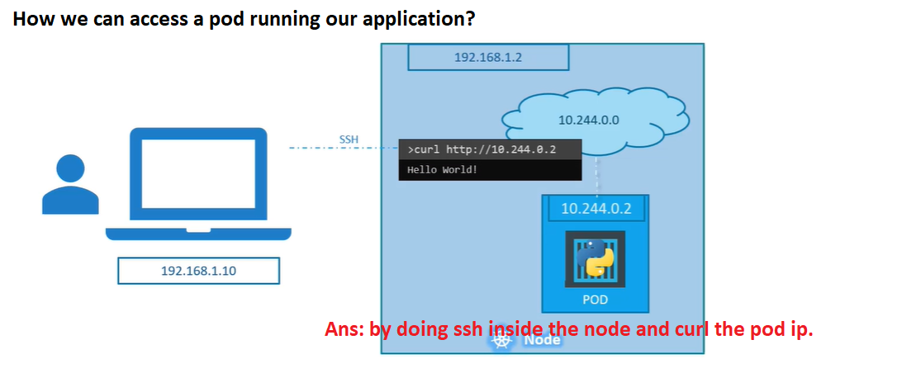

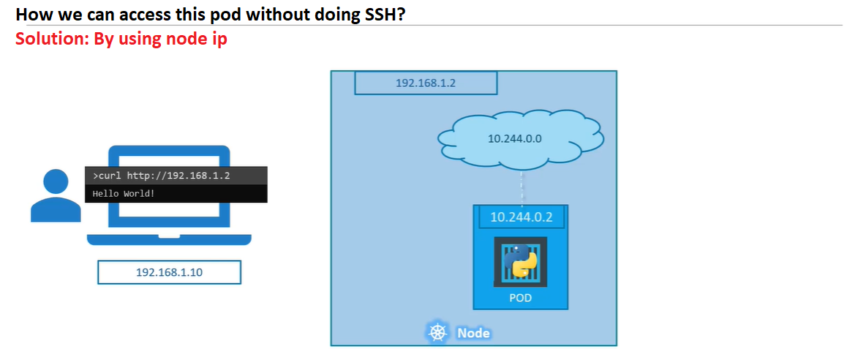

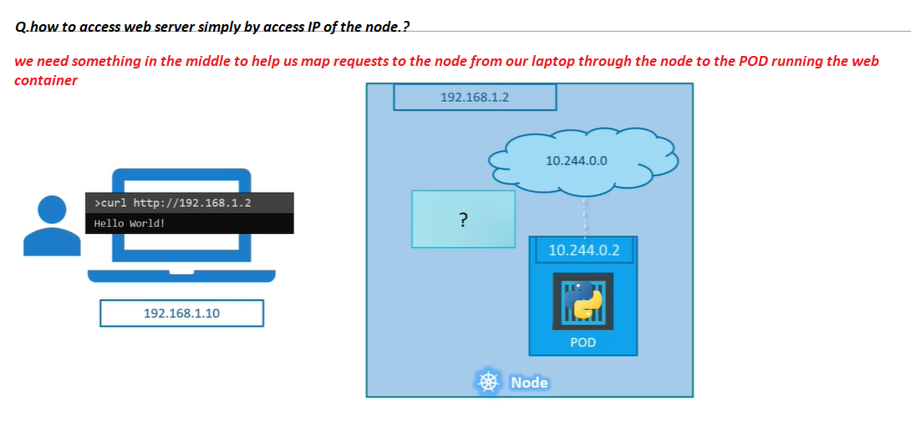

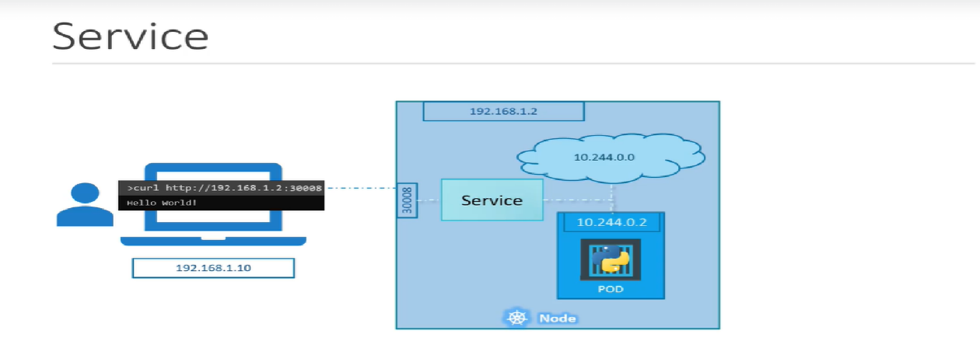

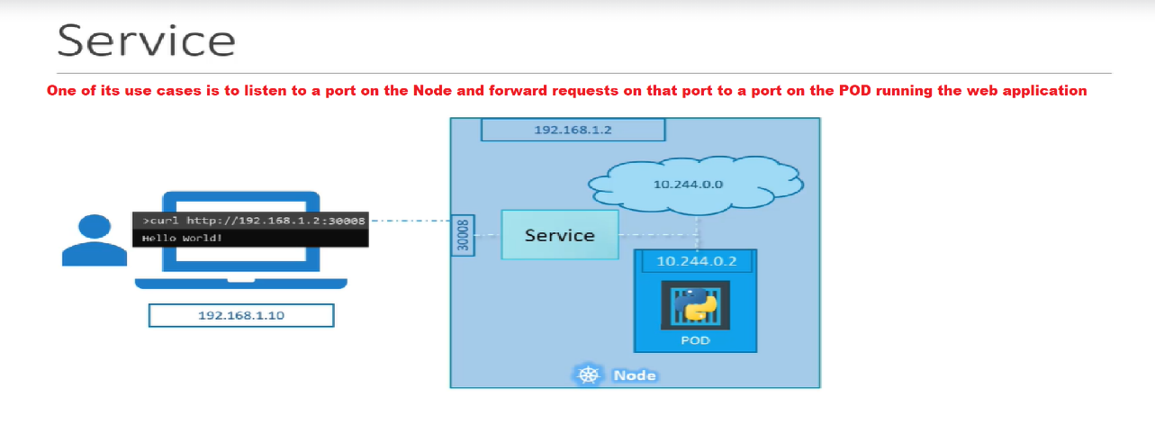

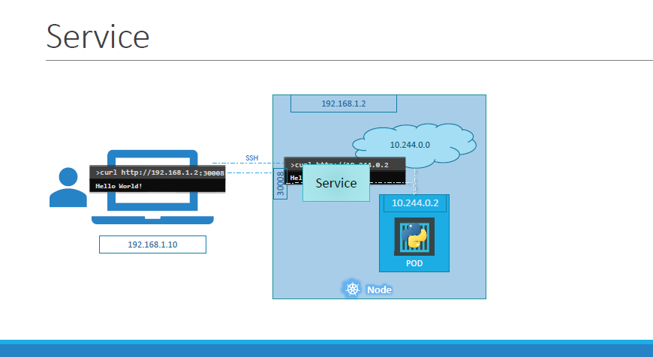

* For external communication. So, we deployed our POD having a web application running on it. How do we as an external user access the web page?
* First of all, let’s look at the existing setup. The Kubernetes Node has an IP address and that is 192.168.1.2. My laptop is on the same network as well, so it has an IP address 192.168.1.10. The internal POD network is in the range 10.244.0.0 and the POD has an IP 10.244.0.2. Clearly, I cannot ping or access the POD at address 10.244.0.2 as it’s in a separate network. So, what are the options to see the webpage?
* First, if we were to SSH into the Kubernetes node at 192.168.1.2, from the node, we would be able to access the POD’s webpage by doing a curl or if the node has a GUI, we could fire up a browser and see the webpage in a browser following the address http://10.244.0.2. But this is from inside the Kubernetes Node and that’s not what I really want.
* I want to be able to access the web server from my own laptop without having to SSH into the node and **simply by accessing the IP of the Kubernetes node**.
* ***So, we need something in the middle to help us map requests to the node from our laptop through the node to the POD running the web container.***
* That is where the Kubernetes service comes into play. The Kubernetes service is an object just like PODs, Replicaset or Deployments that we worked with before. **One of its use cases is to listen to a port on the Node and forward requests on that port to a port on the POD running the web application**. This type of service is known as a **NodePortservice** because the service listens to a port on the Node and forwards requests to PODs.

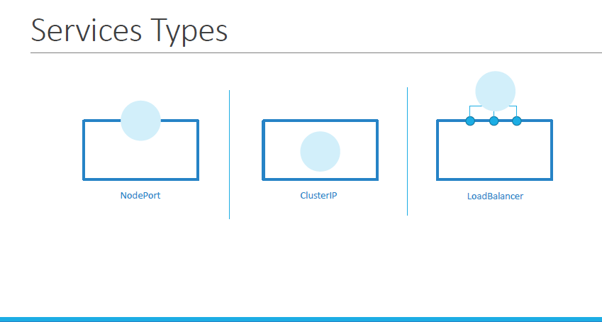

* **NodePort** where the service makes an **internal POD accessible on a Port on the Node.**
* **The second is ClusterIP** and in this case the service creates a virtual IP inside the cluster to enable communication between different services such as a set of front-end servers to a set of backend-servers.
* **The third type is a LoadBalancer**, where it provisions a load balancer for our service in supported cloud providers. A good example of that would be to distribute load across different web servers.

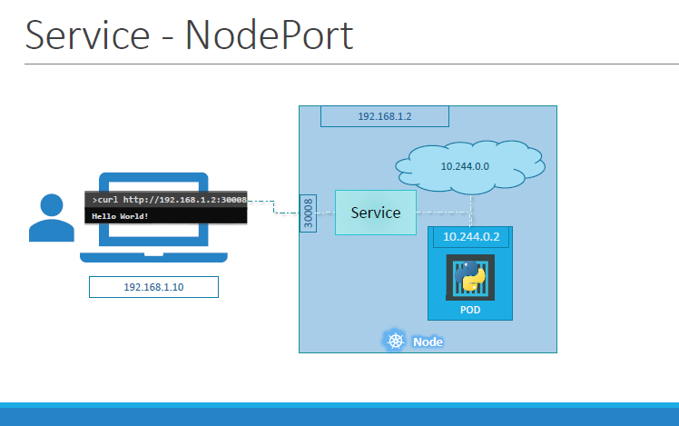

* For external access to the application. We said that a Service can help us by mapping a port on the Node to a port on the POD.

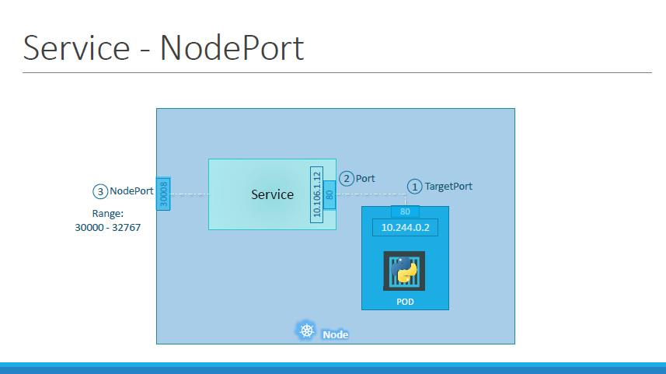

* Let’s take a closer look at the **Service**. If you look at it, there are **3 ports involved**. The port on the POD were the **actual web server is running** is port 80. And it is referred to as the **targetPort**, because that is where the service forwards the requests to.
* The second port is the **port on the service itself**. It is simply referred to as the port**. The service is in fact like a virtual server inside the node**.
* Inside the cluster it has **its own IP address**. And that IP address is called the **Cluster-IP** of the service.
* And finally, we have the port on the Node itself which we use to **access the web server externally**. And that is known as the **NodePort**. As you can see it is 30008. That is because **NodePorts** can only be in a valid **range which is from 30000 to 32767**.

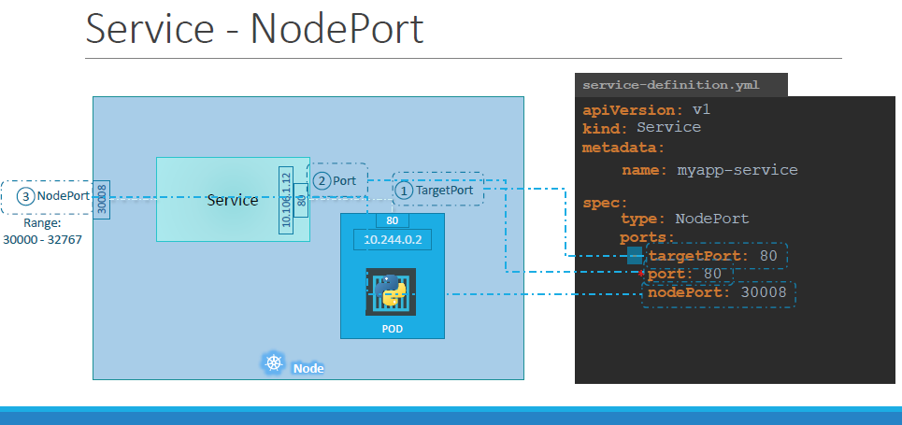

* In the **spec** section of a service we have **type** and **ports**. The **type refers to the type of service we are creating** like ClusterIP, NodePort, or LoadBalancer.
* Remember that out of these, the only **mandatory field is port.**
* If you don’t provide a **targetPort** it is assumed to **be the same as port** and if you don’t provide a **nodePort** **a free port in the valid range between 30000 and 32767 is automatically allocated**.
* **Use Case:-**

There is nothing here in the definition file **that connects the service to the POD**. We have simplyspecified the targetPort but we didn’t mention the targetPort on which POD. There could be 100s of other PODs with web services running on port 80. So how do we do that?

***Solution:*** In kubernetes, we will use labels and selectors to link these together.

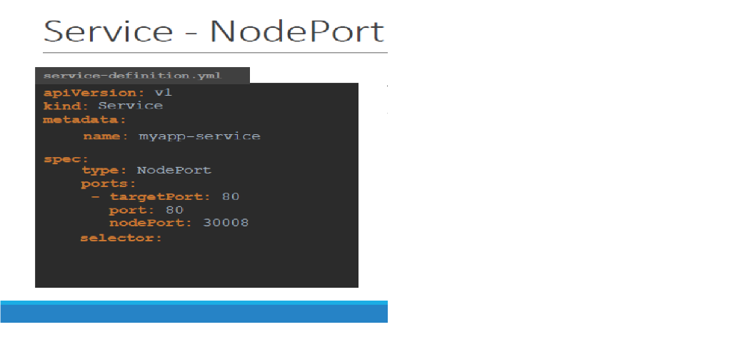

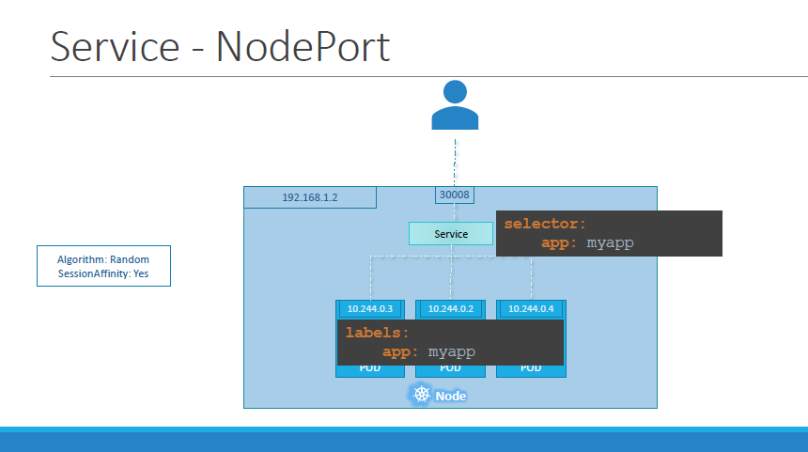

* So far we talked about a service mapped to a single POD. But that’s not the case all the time, what do you do when you have multiple PODs?
* In a production environment you have multiple instances of your web application running for high-availability and load balancing purposes.
* In this case we have multiple similar PODs running our web application. They all have the same **labels** with a key app set to value myapp. The same label is used as a selector during the creation of the service.

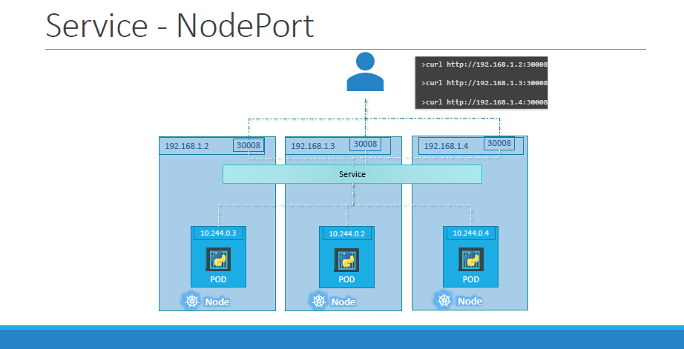

* So, when the service is created, it looks for matching PODs with the labels and finds 3 of them. The **service then automatically selects all the 3 PODs as endpoints to forward the external requests coming from the user**.
* You don’t have to do any additional configuration to make this happen. And if you are wondering what algorithm it uses to balance load, it uses a **random** algorithm.
* **Thus, the service acts as a built-in load balancer to distribute load across different PODs**.
* **Service Type-ClusterIP**

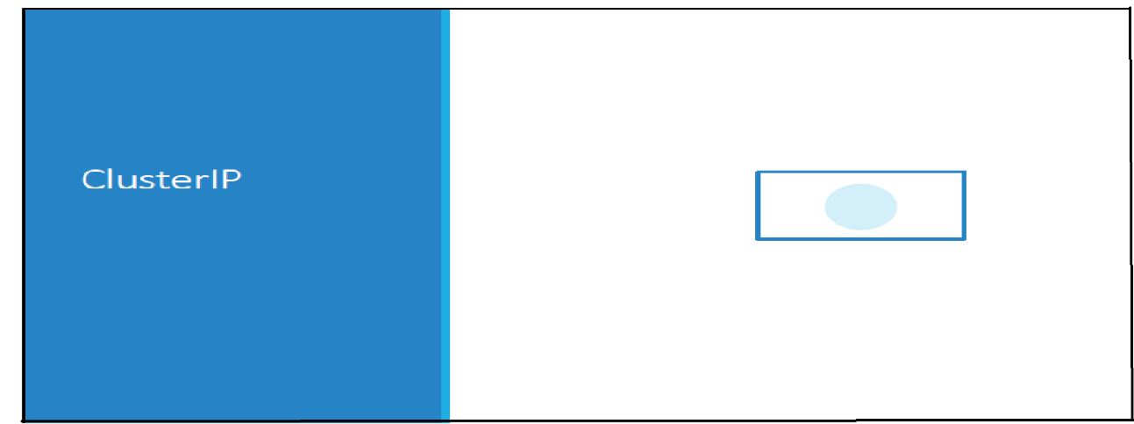

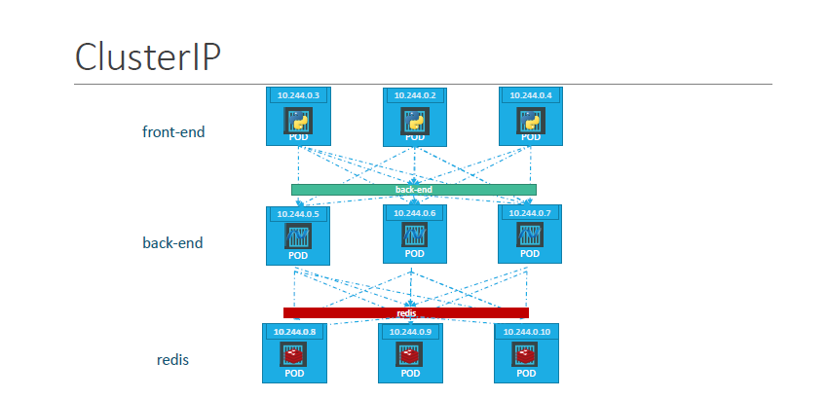

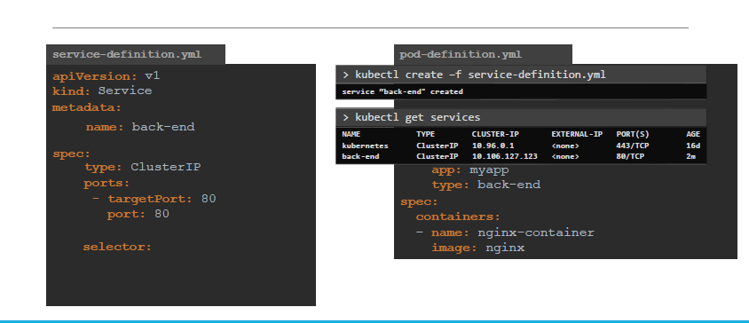

* A **kubernetes service** can help us **group these PODs together and provide a single interface** to **access the PODs in a group**. For example, a service created for the backend PODs will help group all the backend PODs together and provide a **single interface** for other PODs to **access** this service.
* **The requests are forwarded to one of the PODs under the service randomly**. Similarly, create additional services for Redis and allow the backend PODs to access the Redis system through this service. This enables us to easily and effectively deploy a microservices based application on Kubernetes cluster. Each layer can now scale or move as required without impacting communication between the various services. **Each service gets an IP and name assigned to it inside the cluster and that is the name that should be used by other PODs to access the service. This type of service is known as ClusterIP**.
* ***Commands: -***
* kubectl create -f service-definition.yaml
* kubectl get service or kubectl get svc
* minikube service <name-service> --url ( to get the complete url)

***Microservice-Application***

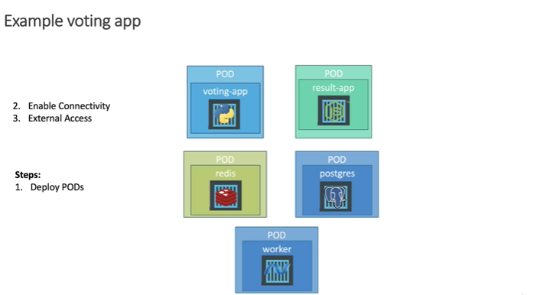

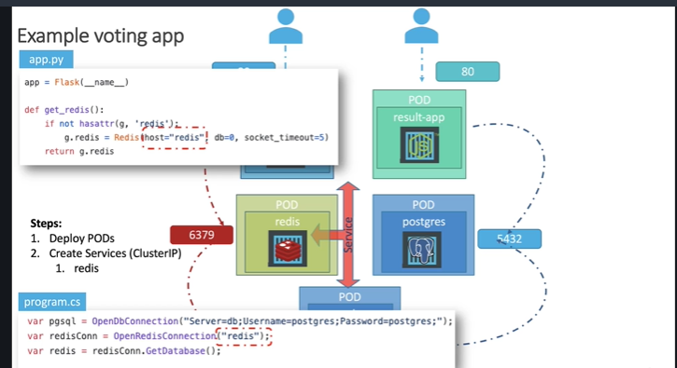

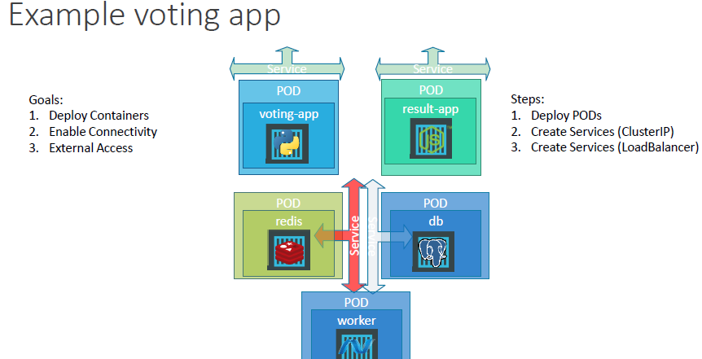

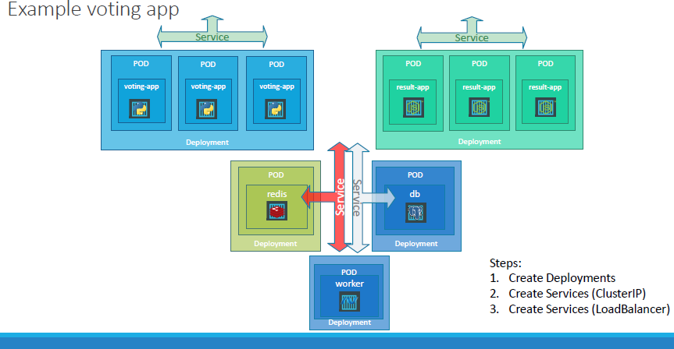

* **Now we improvised our setup using Deployments. We chose deployments over ReplicaSets**

**as Deployments automatically create replica sets as required and it can help us perform rolling updates and roll backs etc.**

namespace

readynessprobe

livenessprobe

secrets

resource

argument

command

**Command and Arguments**

* when we run a ubuntu container from the ubuntu image. It runs a ubuntu instance and **exit** **immediately**.

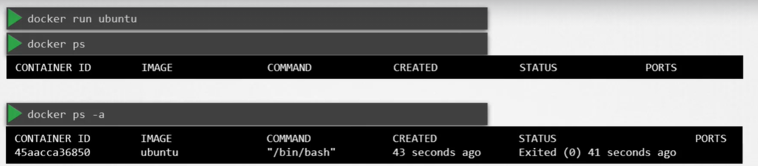

* **Why like that?,** because container is not like the virtual machine, container is not meant to host OS, container is meant to run specific task or process, such as to host an instance of a web server or application server or a database or simply to carry out some kind of computation or analysis.
* Once the task is complete the container exits.
* The container only lives as long as the process inside is alive.
* If the web service inside the container is stopped or crashes, the container exits.
* ***Who defines what process is run within the container?***

Inside the docker file, **CMD** instruction which stands for a command that defines the program that will be run within the container when it starts.



* In above discussed scenario, when we run the ubuntu container, Docker creates a container from the ubuntu image and launched the bash program, by default docker does not attach a terminal to a container when it is run and so the bash program does not find the terminal and so it exits.



* Since the process that was started when the container was created finished the container exit as well.
* ***How we specify the different command***

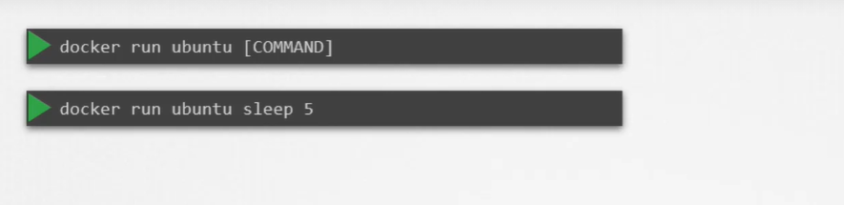

* ***To change the commad and make it permanent create our own image by using ubuntu image***

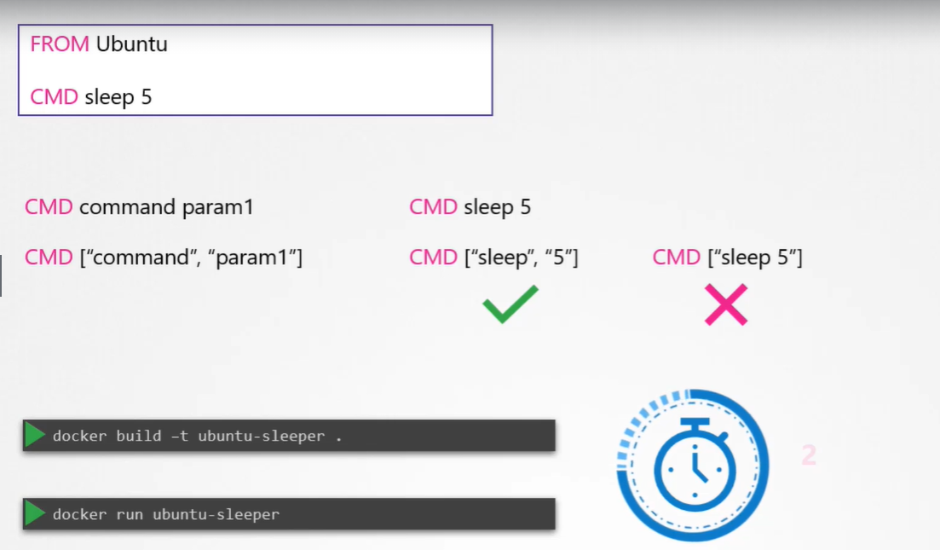

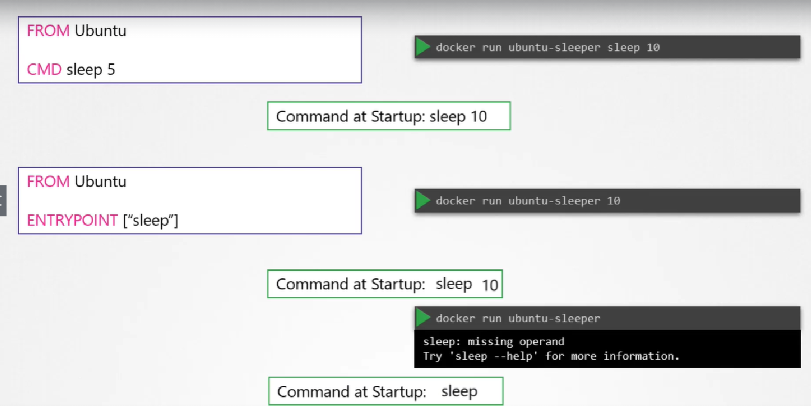

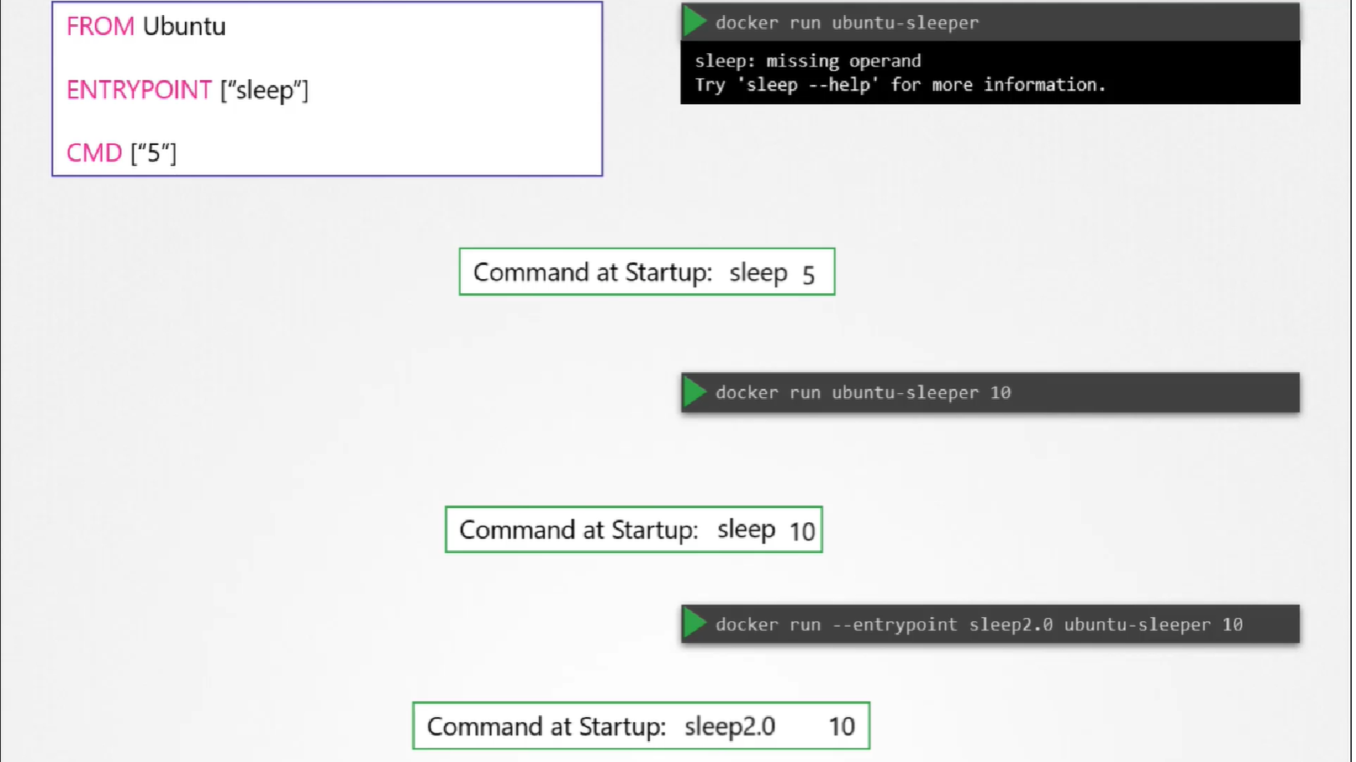

***Note:***

* 1. ***CMD replaces the whole command where as ENTRYPOINT appended the CMD value.***
  2. ***ENTRYPOINT is the command that runs at startup and CMD is the default parameter to that command.***
* Anything that is appended to the docker run command will go into the “args” property of the pod definition file, in the form of an array like this.

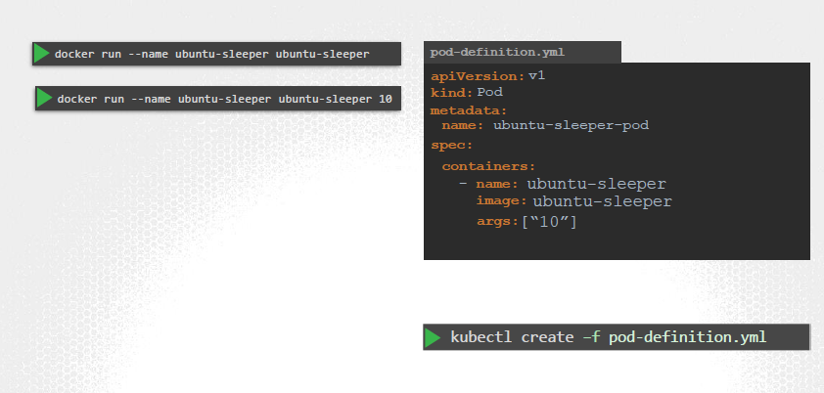

**To change the Entrypoint’s command**

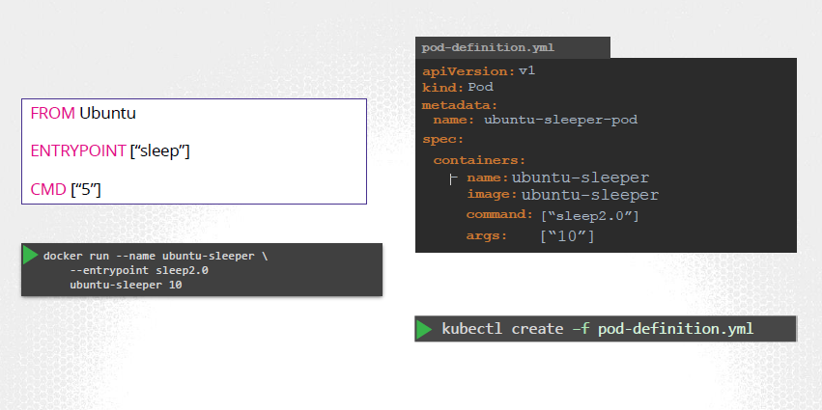

* There are two fields that correspond to two instructions in the Dockerfile.
* The **command** overrides the **entrypoint** instruction and the **args** field overrides the **command** instruction in the Dockerfile.

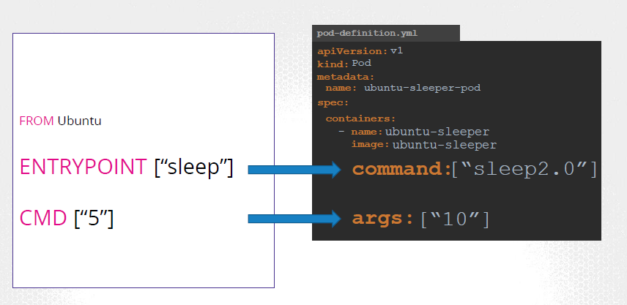

**Environment Variable**

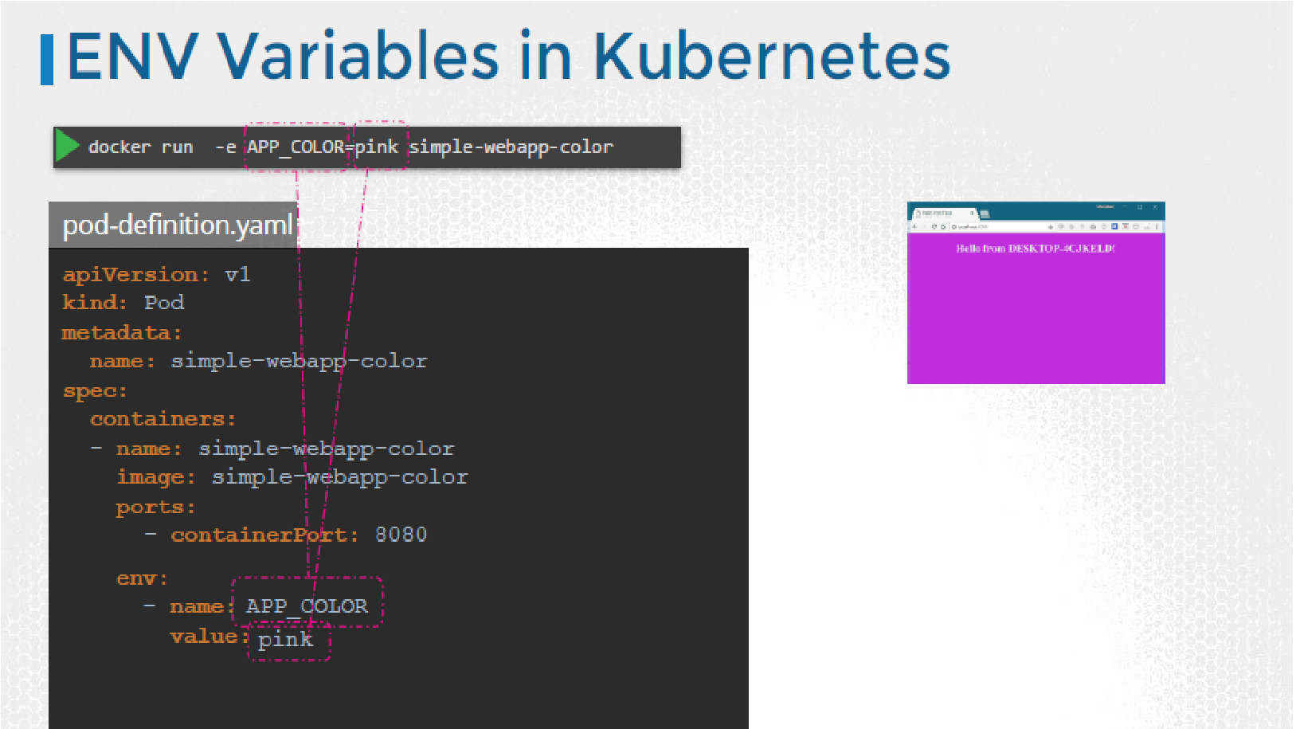

* ***how to pass in an environment variable in Kubernetes.***
* To set an environment variable, use the ENV property.
* ENV is an array. So every item under the env property starts with a dash, indicating an item in the array. Each item has a name and a value property.
* The name is the name of the environment variable made available within the container and the value is its value.

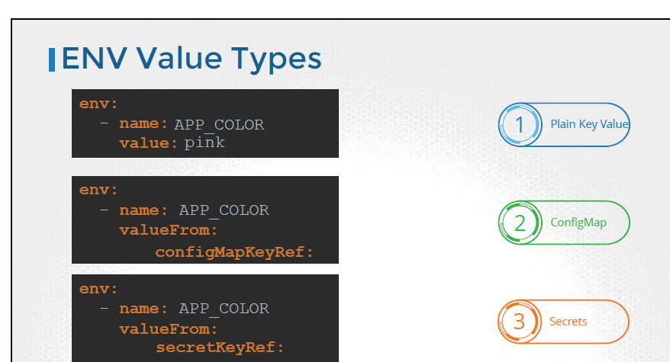

**Resource Requirement**

* Let us consider a 3 Node Kubernetes cluster. Each node has a set of CPU, Memory and Disk resources available.

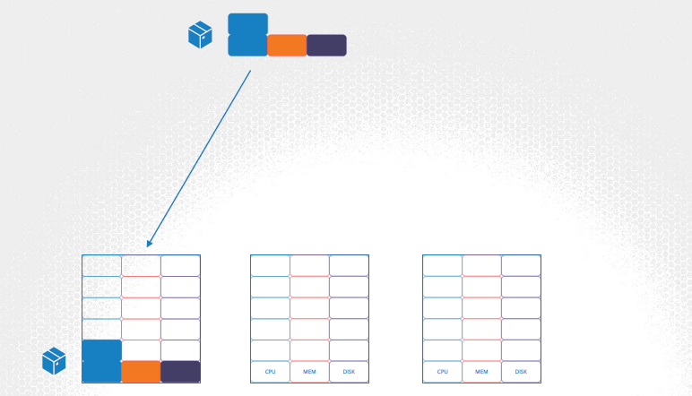

* Every POD consumes a set of resources. In this case 2 CPUs, one Memory and some disk space. Whenever a POD is placed on a Node, it consumes resources available to that node.
* The Kubernetes scheduler that decides which Node a POD goes to.

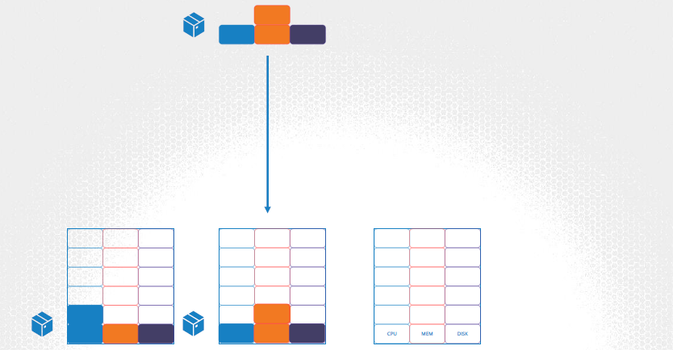

* The scheduler takes into consideration, the amount of resources required by a POD and those available on the Nodes. In this case, the scheduler schedules a new POD on Node 2.

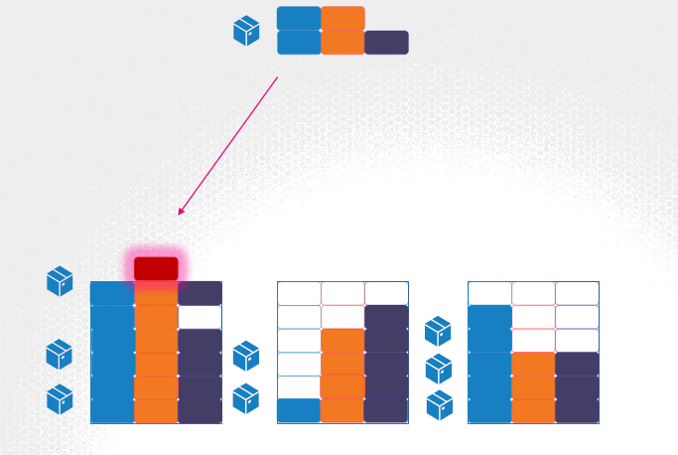

* If the node has no sufficient resources, the scheduler avoids placing the POD on that node.

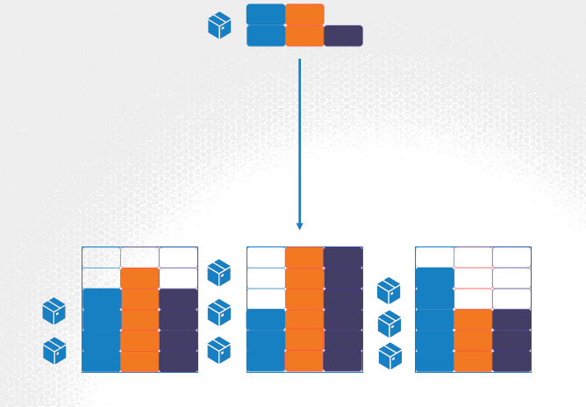

* Instead places the POD on one were sufficient resources are available.

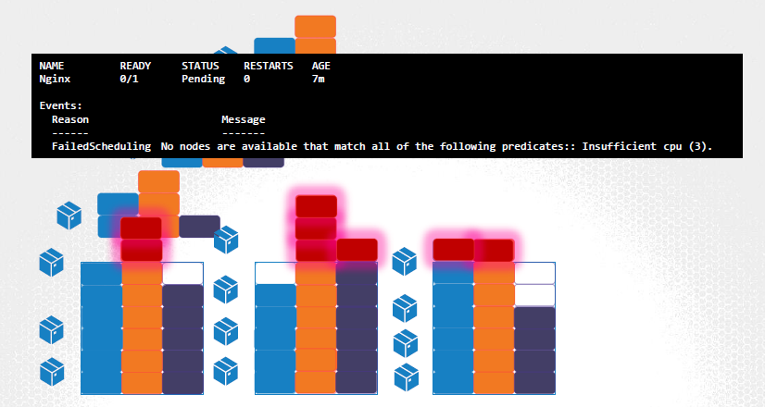

* If there is no sufficient resources available on any of the nodes, Kubernetes holds back scheduling the POD, and you will see the POD in a pending state.
* If you look at the events, you will see the reason –insufficient cpu.

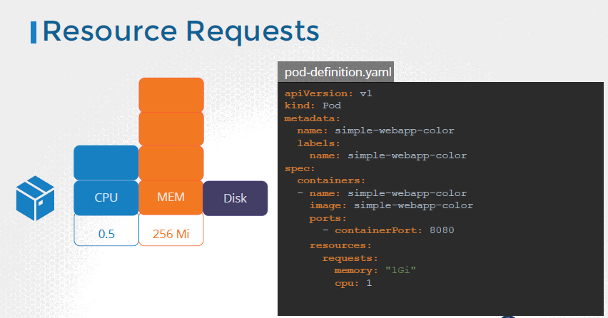

* By default, Kubernetes assumes that a POD or a container within a POD requires .5 CPU & 256 Mebibyte of memory. This is known as the **resource request** for a container. The minimum amount of CPU or Memory requested by the container.
* When the scheduler tries to place the POD on a Node, it uses these numbers to identify a Node which has sufficient amount of resources available.
* Now, if you know that your application will need more than these, you can modify these values, by specifying them in your POD or deployment definition files.

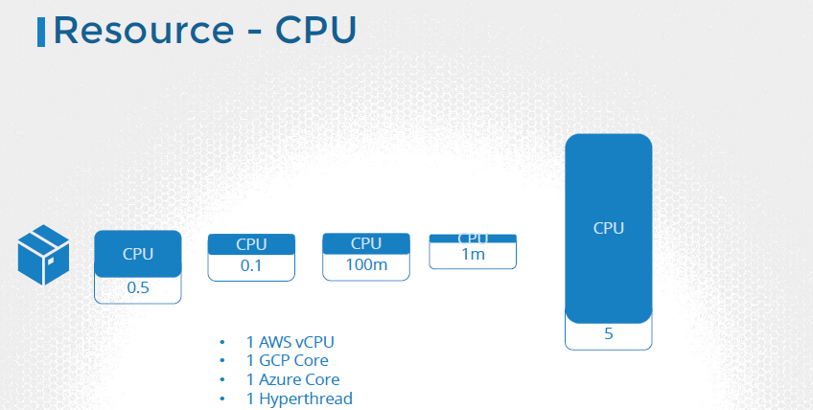

* You could request a higher number of CPUs for the container, provided your Nodes are sufficiently funded.

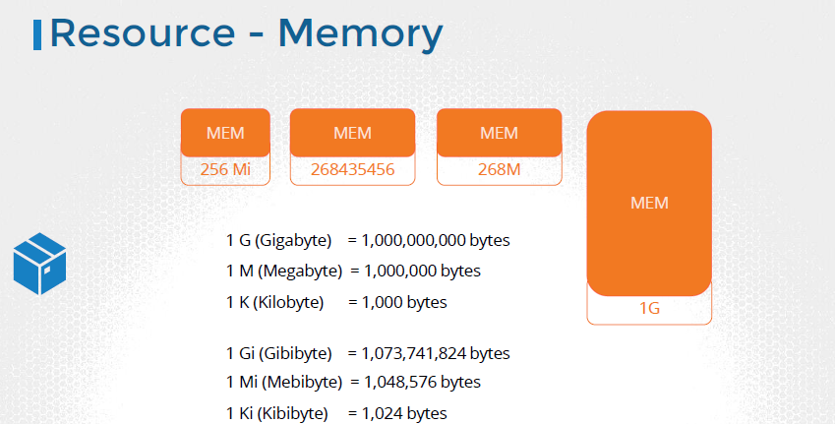

* Let’s now look at a container running on a Node. In the Docker world, a docker container has no limit to the resources it can consume on a Node. Say a container starts with 1 vCPU on a Node, it can go up and consume as much resource as it requires, suffocating the native processes on the node or other containers of resources.

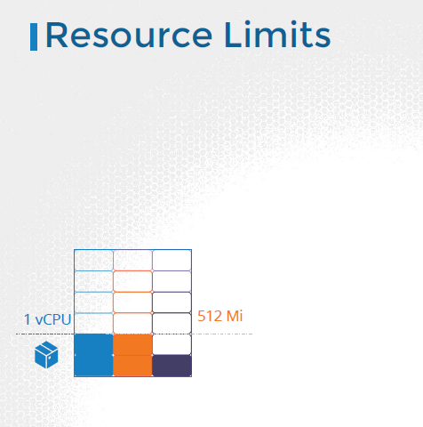

* However, you can set a limit for the resource usage on these PODs. **By default**, Kubernetes sets a limit of **1vCPU** to containers. So if you do not specify explicitly, a container will be limited to consume only 1 vCPU from the Node.
* The same goes with memory. By **default**, kubernetessets a limit of **512** Mebibyte on containers.

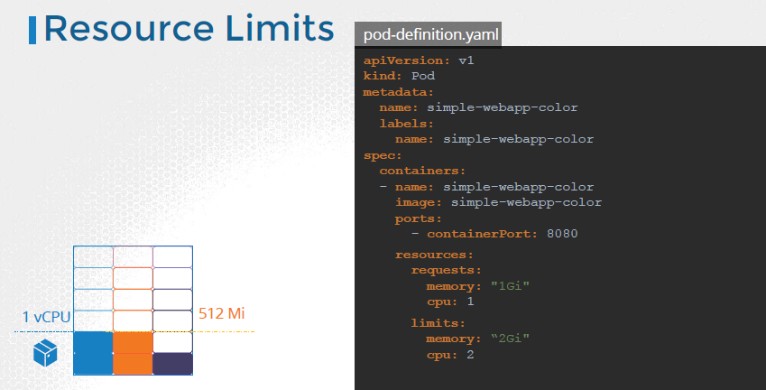

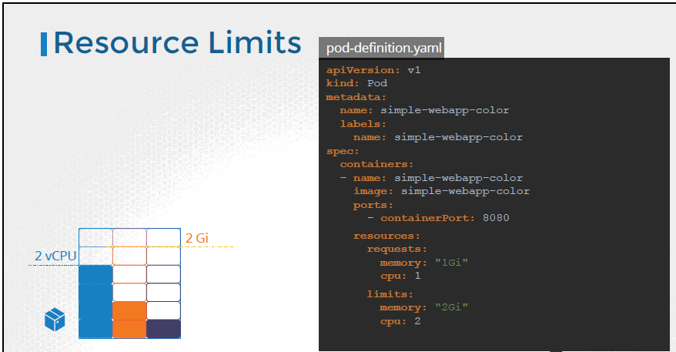

* When the pod is created, kubernetes sets new limits for the container. Remember that the limits and requests are set for each container.

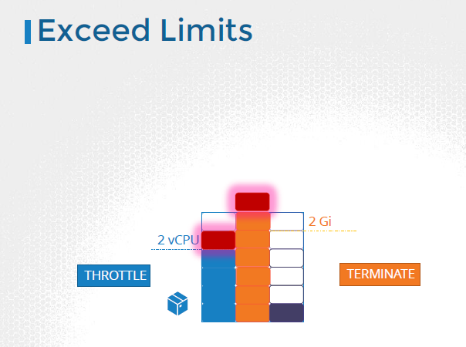

* ***what happens when a pod tries to exceed resources beyond its specified limit?***
* In case of the CPU, kubernetes throttles the CPU so that it does not go beyond the specified limit. A container cannot use more CPU resources than its limit.
* However, this is not the case with memory. A container CAN use more memory resources that its limit. So if a pod tries to consume more memory than its limit constantly, the POD will be **terminated**.

<https://kubernetes.io/docs/tasks/administer-cluster/manage-resources/memory-default-namespace/>

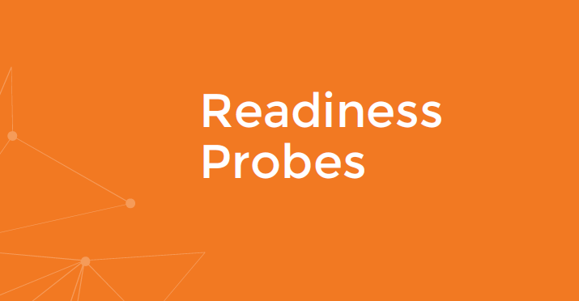

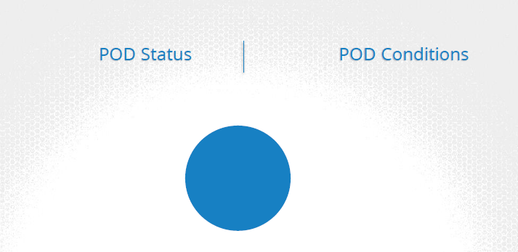

* A POD has a pod status and some conditions.
* The POD status tells us were the POD is in its lifecycle.
* When a POD is first created, it is in a **Pending state**. This is when the Scheduler tries to figure out were to place the POD. If the scheduler cannot find a node to place the POD, it remains in a Pending state. To find out why it’s stuck in a pending state, run the **kubectl describe pod command**, and it will tell you exactly why.
* Once the POD is scheduled, it goes into a **ContainerCreating** status, were the images required for the application are pulled and the container starts.
* Once all the containers in a POD starts, it goes into a **running** state, were it continues to be until the program completes successfully or is terminated.
* **Conditions** compliment POD status. It is an array of **true** or **false** values that tell us the **state** of a POD.

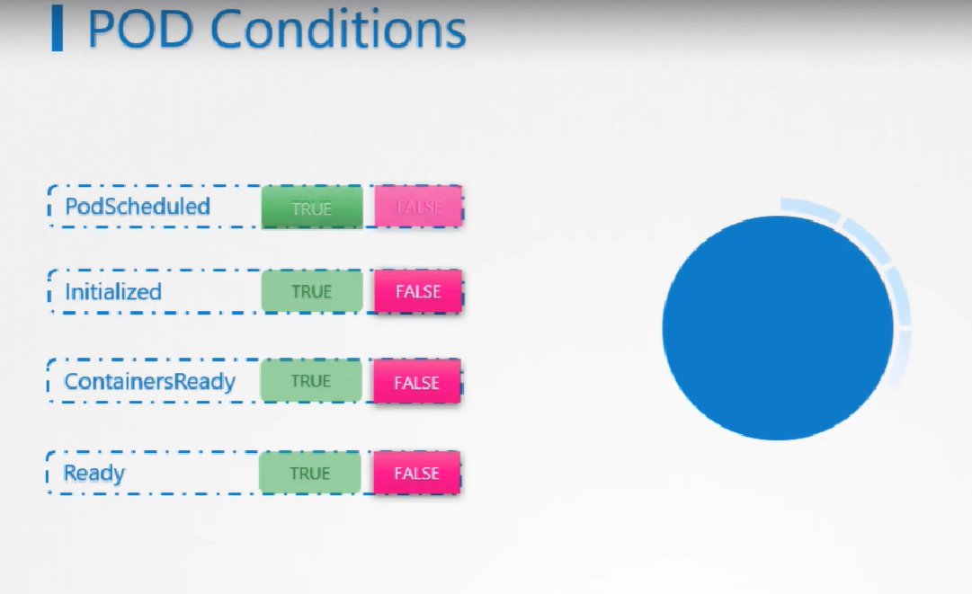

* When a POD is scheduled on a Node, the Pod Scheduled condition is set to **True**. When the POD is initialized, it’s value is set to True. We know that a POD has multiple containers. When all the containers in the POD are ready, the Containers Ready condition is set to True and finally the POD itself is considered to be Ready.
* To see the state of POD conditions run the **kubectl describe POD** command and look for the conditions section.

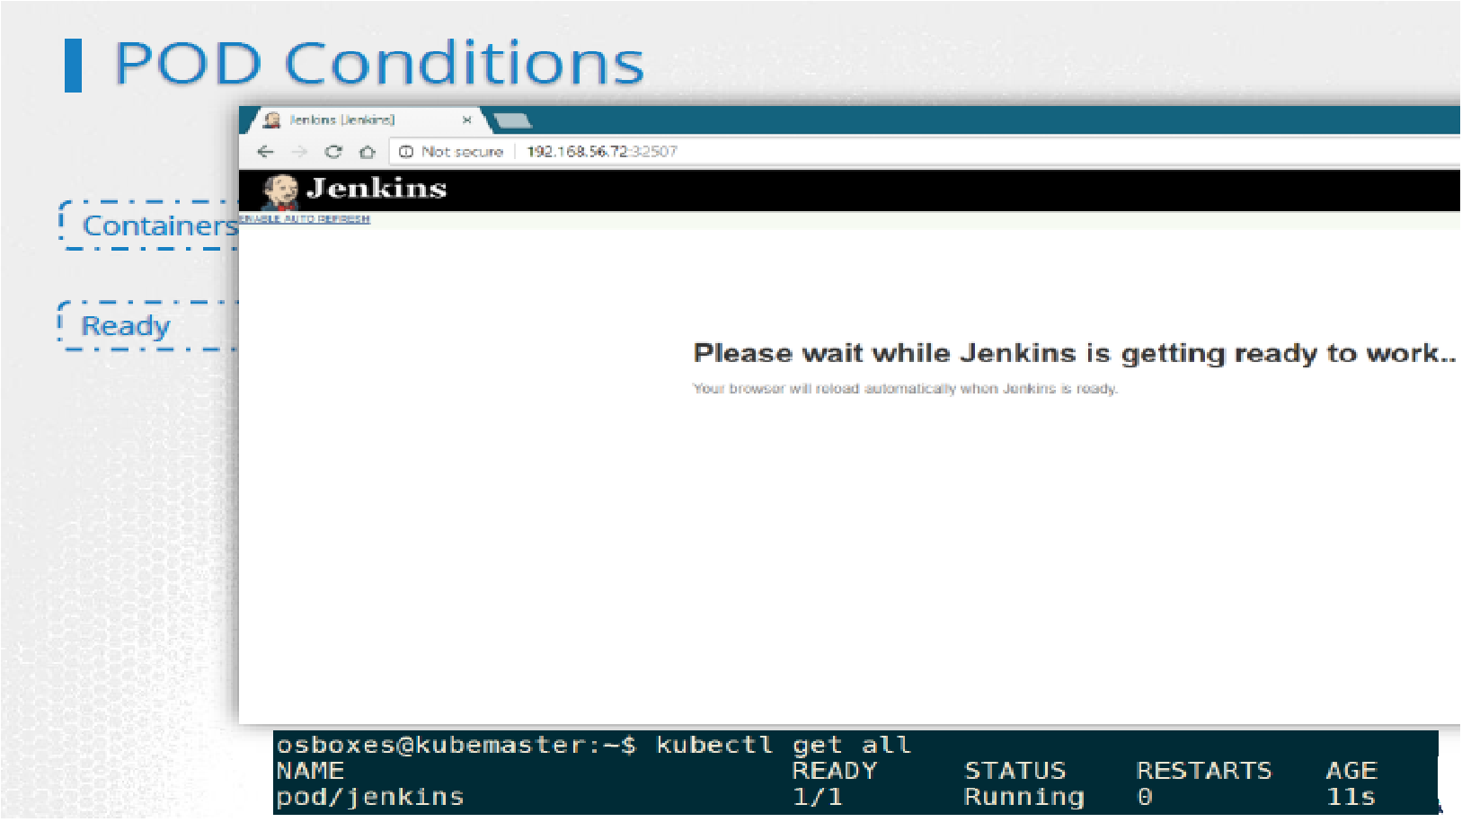

* The ready conditions indicate that the application inside the POD is running and is ready to accept user traffic. What does that really mean?
* If you try to run an instance of a Jenkins server, you will notice that it takes about 10-15 seconds for the server to initialize before a user can access the web UI. Even after the Web UI is initialized, it takes a few seconds for the server to warm up and be ready to serve users. During this wait period if you look at the state of the POD, it continues to indicate that the POD is **ready**, which is not very true.
* **So why is that happening and how does kubernetes know weather that the application inside the container is actually running or not**?
* Let us consider a simple scenario where you create a POD and expose it to external users using a service. The service will route traffic to the POD immediately. **The service relies on the pod’s READY condition to route traffic.**

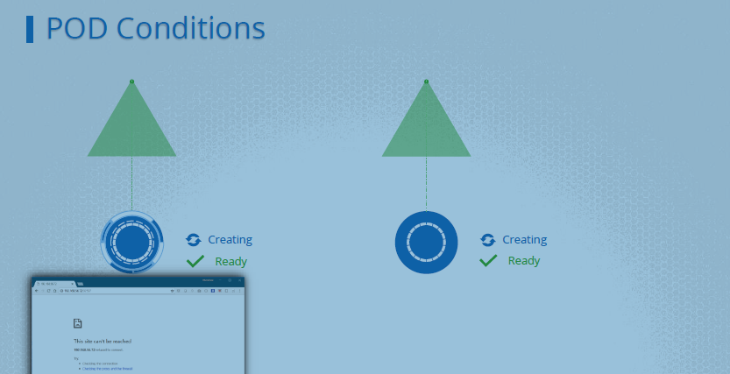

* By default, Kubernetes assumes that as soon as the container is created, it is ready to serve user traffic. So it sets the value of the “Ready Condition” for each container to True. But if the application within the container took longer to get ready, the service is unaware of it and sends traffic through as the container is already in a ready state, causing users to hit a POD that isn’t yet running a live application.
* What we need here is a way to tie the ready condition to the actual state of the application inside the container. As a developer we know what does it means to be application to be ready.

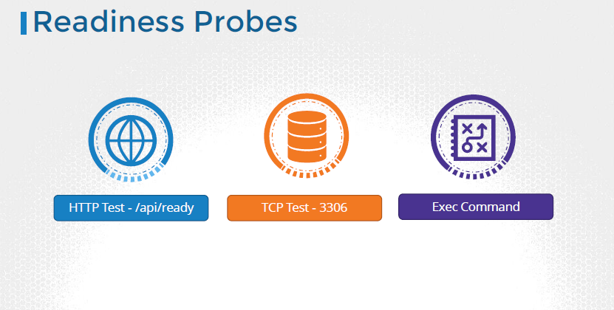

* There are different ways that you can define if an application inside a container is actually ready.

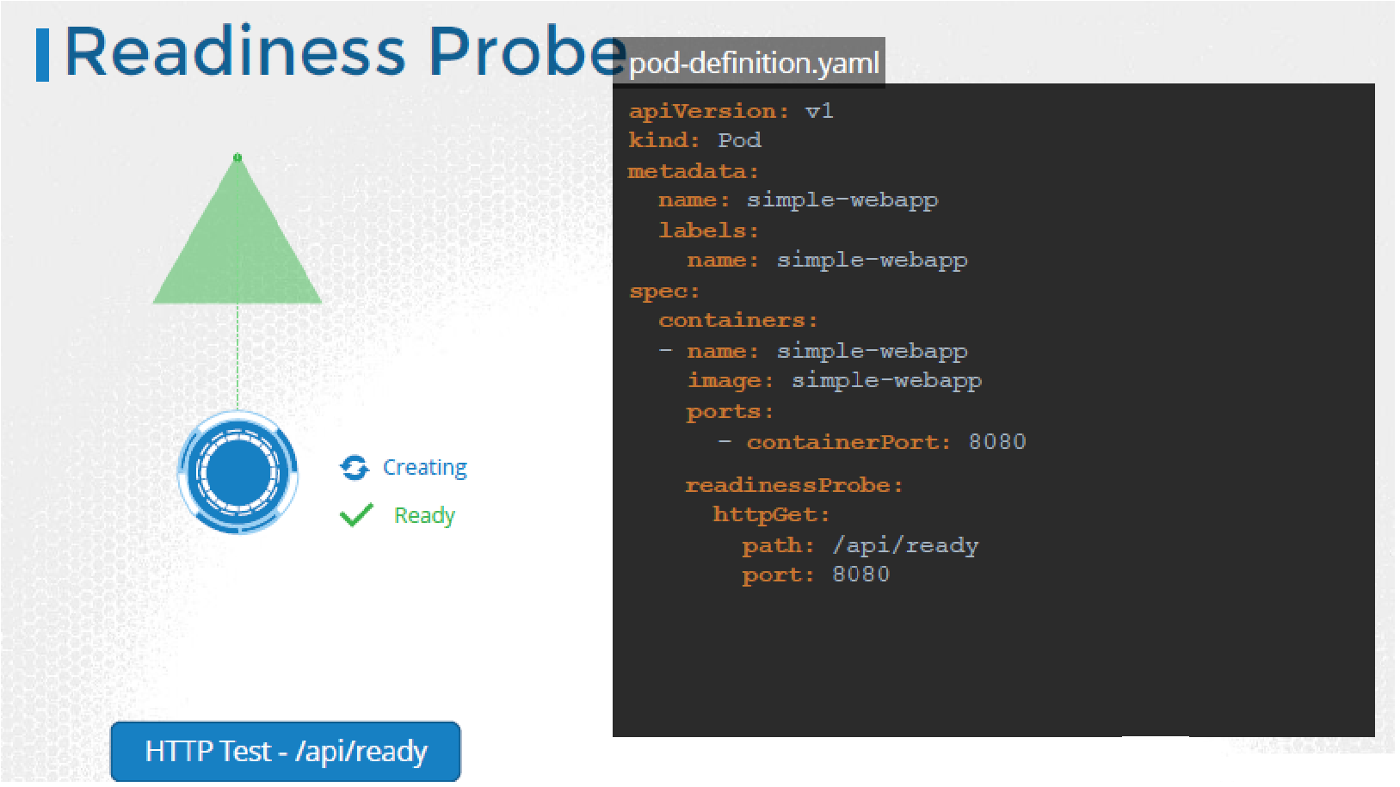

* You can setup different kinds of tests or Probes, which is the appropriate term. In case of a web application it could be when the API server is up and running. So you could run a HTTP test to see if the API server responds.
* In case of database, you may test to see if a particular TCP socket is listening.

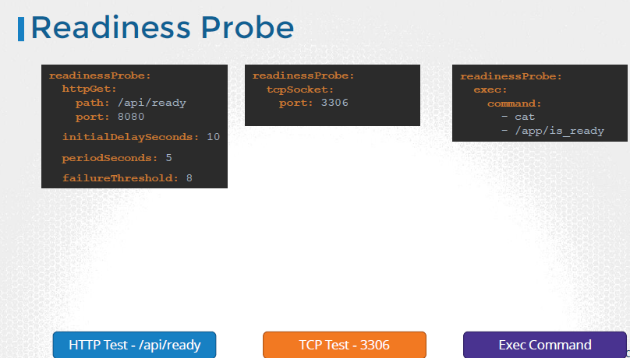

* You may simply execute a command within the container to run a custom script that would exit successfully if the application is ready.
* There are some additional options as well. If you know that your application will always take a minimum of, say, 10 seconds to warm up, you can add an **initialdelaySeconds** to the probe.
* If you’d like to specify how often to probe, you can do that using the **periodSeconds** option.
* By default if the application is not ready after 3 attempts, the probe will stop. If you’d like to make more attempts, use the **failureThreshold** option.

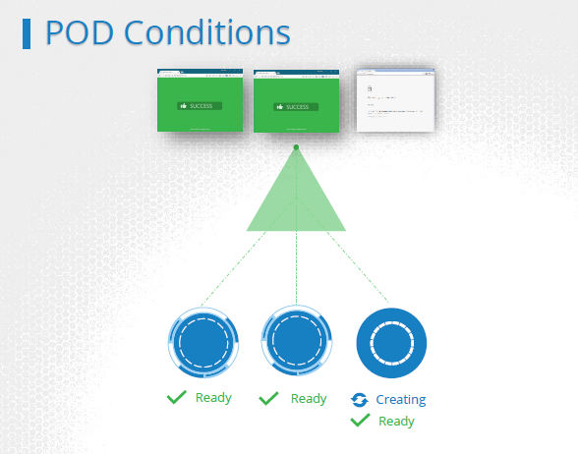

* **ReadinessProbes** are useful in a multi-pod setup. Say you have a replica set or deployment with multiple pods. And a service serving traffic to all the pods. There are two PODs already serving users. Say you were to add an additional pod. And let’s say the Pod takes a minute to warm up. Without the readinessProbe configured correctly, the service would immediately start routing traffic to the new pod. That will result in service disruption to at least some of the users.
* Instead if the pods were configured with the correct readinessProbe, the service will continue to serve traffic **only to the older pods and wait until the new pod is ready**. Once ready, traffic will be routed to the new pod as well, ensuring no users are affected.

<https://kubernetes.io/docs/tasks/configure-pod-container/configure-liveness-readiness-probes/>

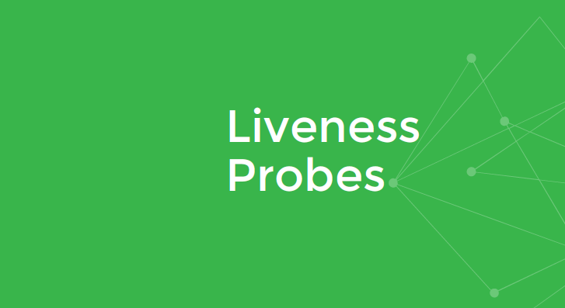

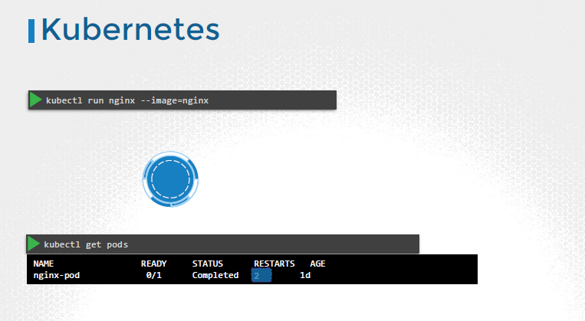

* A liveness probe can be configured on the container to periodically test whether the application within the container is actually healthy. If the test fails, the container is considered unhealthy and is destroyed and recreated.

